1. WWW Support Introduction 4
1.1. What is WWW Support 4
1.2. Roadmap to WWW Support documentation 4
1.3. System deployment 5
1.4. Requirements 5
1.5. Copyright and Legal Information 5
2. WWW Support User’s Guide 5
2.1. Using "Administration" 5
2.1.1 Roles 5
2.1.2 Project 6
2.1.3 User 6
2.2. Using "Content Manager" 7
2.3. Using "Forum" 8
2.4. Using "Feedback" 9
2.5. Using "Bug Tracking" 10
2.6. Using "Message Templates" 12
2.7. Using "Mail System" 12
2.8. Interface features 12
3. WWW Support Reference 13
3.1. General interface 13
3.1.1 Entering the system 13
3.1.2 Home page 13
3.1.3 System menu 14
3.2. "Administration" subsystem 18
3.2.1 "User Profile: [user]" page 18
3.2.2 "SAdmin: User Groups" page 20
3.2.3 "SAdmin: User List" page 20
3.2.4 "SAdmin: Create New User" page 22
3.2.5 "SAdmin: Edit User Information: [user]" page 23
3.2.6 "SAdmin: User Roles: [user]" page 25
3.2.7 "SAdmin: Edit User Roles in Projects: [user]" page 26
3.2.8 "SAdmin: Project List" page 26
3.2.9 "SAdmin: Project Users: [project]" page 27
3.2.10 "SAdmin: Adding User to Project: [project]" 29
3.2.11 "SAdmin: Mail Templates: Template Configuration" page 30
3.2.12 "SAdmin: Account Status: [account]" page 31
3.2.13 "SAdmin: Color Themes: Color Themes List" page 32
3.2.14 "SAdmin: Color Themes: Color Theme Configuration" page 33
3.2.15 "SAdmin: Database Export" page 35
3.2.16 "SAdmin: Database Import" page 36
3.2.17 "SAdmin: Banner System: Banners List" page 36
3.2.18 "SAdmin: Banner System: Banner Information" page 37
3.2.19 "SAdmin: Banner System: Banner Slot Placement" page 39
3.2.20 "SAdmin: Mail System: Mail List" page 40
3.2.21 "SAdmin: Mail System: Compose New E-Mail" page 40
3.2.22 "SAdmin: Mail System: Edit E-Mail" page 42
3.2.23 "SAdmin: Mail System: Mail Recipients" page 42
3.3. "Content Manager" subsystem 43
3.3.1 "Content Manager: Categories" page 43
3.3.2 "Content Manager: [category]: Theme List" page 44
3.3.3 "Content Manager: [category]: Create New Theme" page 46
3.3.4 "Content Manager: [category]: Edit Theme Information: [theme]" page 47
3.3.5 "Content Manager: [category]: Edit Permissions: [theme]" page 48
3.3.6 "Content Manager: [category]: Articles List: [theme]" page 49
3.3.7 "Content Manager: [category]: [theme]: Create New Article" page 50
3.3.8 "Content Manager: [category]: [theme]: Edit Article" page 52
3.3.9 "Content Manager: [category]: [theme]: Article detail" page 54
3.3.10 "Content Manager: [category]: Search" page 55
3.3.11 "Content Manager: [category]: Subscription" page 56
3.4. "Forum" subsystem 57
3.4.1 "Forum: Forum List" page 57
3.4.2 "Forum: Create New Forum" page 58
3.4.3 "Forum: Edit Forum Information: [forum]" page 59
3.4.4 "Forum: Edit Permissions: [forum]" page 60
3.4.5 "Forum: Message List: [forum]" page 62
3.4.6 "Forum: [forum]: Create New Message" page 63
3.4.7 "Forum: Subscription" page 64
3.5. "Feedback" subsystem 65
3.5.1 "Feedback: Zone List" page 65
3.5.2 "Feedback: Create New Zone" page 66
3.5.3 "Feedback: Edit Zone Information: [zone]" page 68
3.5.4 "Feedback: Edit Permissions: [zone]" page 69
3.5.5 "Feedback: Message List: [zone]" page 70
3.5.6 "Feedback: [zone]: Create New Message" page 71
3.5.7 "Feedback: [zone]: Message details" page 73
3.5.8 "Feedback: [zone]: Direct Mail" page 74
3.5.9 "Feedback: Configuration" page 75
3.5.10 "Feedback: Subscription" page 76
3.5.11 "Feedback: Activity Report" page 77
3.5.12 "Feedback: User Activity Report" page 78
3.6. "Bug Tracking" subsystem 79
3.6.1 "Bug Tracking: Issue List" page 79
3.6.2 "Bug Tracking: Create New Issue" page 81
3.6.3 "Bug Tracking: Edit Issue Information: [issue]" page 82
3.6.4 "Bug Tracking: Edit Permissions: [issue]" page 83
3.6.5 "Bug Tracking: Message List: [issue]" page 85
3.6.6 "Bug Tracking: [issue]: Create New Message" page 86
3.6.7 "Bug Tracking: [issue]: Message Details" page 88
3.6.8 "Bug Tracking: [issue]: Direct Mail" page 90
3.6.9 "Bug Tracking: Configuration" page 91
3.6.10 "Bug Tracking: Subscription" page 91
3.6.11 "Bug Tracking: Activity Report" page 92
3.6.12 "Bug Tracking: User Activity Report" page 93
3.7. "Task Manager" subsystem 94
3.7.1 "Task Manager: Task List" page 94
3.7.2 "Task Manager: Task Information: [task]" page 96
3.7.3 "Task Manager: Create New Task" page 97
3.7.4 "Task Manager: Edit Task Information: [task]" page 98
3.7.5 "Task Manager: Involved Users: [task]" page 100
3.7.6 "Task Manager: Edit Permissions: Task Access Permissions" page 101
3.7.7 "Task Manager: Task Statistics" page 102
3.8. "Site Management" subsystem 103
3.8.1 "Site Management: Site List" page 103
3.8.2 "Site Management: Add New Site" page 104
3.8.3 "Site Management: Edit Site" page 106
3.8.4 "Site Management: Menu Editor" page 107
3.8.5 "Site Management: Menu Editor: Page Info Edit (Add Page)" page 108
3.8.6 "Site Management: Menu Editor: Page Info Edit (Edit Page)" page 110
3.9. Using "Site Management" subsystem 112
3.9.1 What do you need to add a new site 112
3.9.2 What do you need to add new pages and build hierarchy of a new site 114
3.9.3 What is required to manage branches and pages 118
3.9.4 What is required to delete some pages 119
3.9.5 What is required to delete the entire site 120
4. Support 120

WWW Support Introduction
This document provides conceptual and reference information for users of WWW Support. The help consists of User’s Guide and Reference sections for each subsystem of WWW Support. For more information on each of these sections, see Roadmap to the WWW Support documentation.
In addition to the sections for each subsystem, this document contains an overview section. This section contains the following topics that provide general information about WWW Support.
- What is WWW Support
- Roadmap to the WWW Support documentation
- System deployment
- Requirements
- Copyright and Legal Information

What is WWW Support
The following are main objectives of WWW Support.
- Provide effective collaboration of distributed development teams
- Creating web based systems for customer support which can include subsystems such as a conference, news, knowledge base, bug tracking, and feedback.

Roadmap to WWW Support documentation
This documentation contains two main sections: User’s Guide, and Reference. User’s Guide introduces the basic functions of WWW Support, and provides conceptual and procedural information. The reference section provides detailed information about WWW Support subsystems, windows, and controls.
The following is a brief description of User’s Guide sections.
Using "Administration"
This section provides information about the administration subsystem including security and system configuration.
Using "Content Manager"
This section introduces the "Content Manager" subsystem which provides functionality of the knowledge base.
Using Forum
This section provides information about the "Forum" subsystem – the subsystem for creating and maintaining conferences and forums.
Using Feedback
This section introduces the "Feedback" subsystem. The "Feedback" subsystem is a powerful user’s support tool. This subsystem tracks user’s requests and dispatches them between support personnel.
Using "Bug Tracking"
This section provides information about the "Bug Tracking subsystem. This section contains conceptual and procedural information about tasks and bug processing.
Using "Message Template"
This section introduces the "Message Template" subsystem. This section describes the creation and usage of message templates.

Using "Mail System"
This section introduces "Mail System" subsystem. This section describes how to organize email notification and newsletter subscriptions for registered users.
Interface features
This section provides information about interface features of WWW Support.

System deployment
WWW Support can be deployed in two modes:

Private deployment
User installs system on his own server. Users reach the system through Internet or Intranet.

FOSS web server deployment
User uses the WWW Support system which is installed on server of FOSS Software Inc. Users reach the system through Internet.

Requirements
Access is recommend using Microsoft Internet Explorer (version 5.0 or later) or Netscape Communicator (4.0 or later), with a screen resolution at least 1024 x 768

Copyright and Legal Information
WWW Support system version 0.1.2 (02/23/04). Copyright © 2000-2004 FOSS Software Inc. All rights reserved.

FOSS Software Inc.
151 Main st. Suite 3
Salem, NH 03079
Ph: (603) 894-6425
(603) 894-6427
Fax: (603) 386-6262
foss@fossware.com

WWW Support User’s Guide

Using "Administration"
Security of WWW Support is based on three entities: role, project, and user.

Roles
Role has predefined permissions to the system objects and functionality. A role is a container for users. You can include or exclude users from a role. You can’t change role access to the system objects. It’s predefined and unchangeable. The following is full list of the system roles.

System Administrator
System Administrator has absolute and unrestricted access to any system resources such as Project Lists, Users Lists, Access Rights assignment and so on. There can be only one System Administrator per organization. A user can be delegated Systems Administrator rights during setup. User Administrator cannot be changed after. The System Administrator entry is typed in bold in all users’ lists.

Administrator
Administrator has the same rights as System Administrator except following difference: you can remove the administrator role from user. Only System Administrator can modify Administrator role.

Project administrator
Project administrator has full access to all resources within the project. Project administrator has authority to create new users, assign them access rights, and create forums, knowledge-base, and other resources. He cannot remove objects from the system and has no access to other projects.

Project manager
Project manager has access to objects only within a certain project and a certain group. He can make comments, redirect bugs to other project participants, change their status, and so on.

Project user
Project user has no predefined rights.

Anonymous
Anonymous is an unauthorized user. He has no login name and password. Anonymous can reach public resources such as Forum or Knowledge Base. Administrator can give Anonymous additional permissions.

Project
Project is a set of system resources. You can divide all processes of your company into projects. It helps organize the complex structure of a company into group resources such as users’ permissions, forums, knowledge bases and etc. Only a System Administrator can create or remove projects.
All projects have their own users permissions set. The user who has permissions to a project doesn’t transfer those permissions to other projects.
After deployment WWW Support has one project which is named "Public". The "Public" project is a primary project of the system and cannot be deleted.

User
User is a base object of security. All projects share a single user list but every project has its own user profile for each user.
The security configuration process is either inclusion or exclusion of users from roles. The user who is not assigned to any role of project is considered as Anonymous. He has access only to public objects. Administrator must include a user in a role to give the user permissions to the corresponding objects.
The system checks user authorization on the interface and the database levels. On the interface level the system prevents users from any misuse errors. The interface authorization level is just an auxiliary method of authorization because the main business processes take place on the server side. The database authorization level checks every database query and guarantees correctness of user actions.
All system variables have a lifespan of, by default, 20 minutes. This means, if an authorized user has been inactive for 20 minutes, the system will ask the user to login order to continue the work. Working anonymously doesn’t imply such limitations.

Using "Content Manager"
Content Manager Subsystem is a universal knowledge base. It can include articles, notes, descriptions, etc. You can easily store and find necessary information as well as protected information accessed through the security subsystem. Moreover, the content manager subsystem can be used as a universal tool for implementing features on your website such as FAQ, News, Product Description and etc.

Articles formatting
The Article is the elemental part of the Content Manager subsystem. Every article has the following attributes:
- Title – up to 1000 symbols;
- Summary - up to 1000 symbols;
- Keywords – up to 1000 symbols. They are intended for fast searching. You can enter any word or word combinations separated by a space.
- Published – can have the following parameters: unpublished, published on the date of publication, published.
- Article body – the text of an article.
- Attached files – every article can have up to 3 attachments with size no more than 500K each.
An article body can include tags for highlighting some parts of the text, such as italic or bold. If you make hyperlinks within the article body to other resources in the form of a URL, they will be displayed as active hyperlinks. For example, the text www.w3spt.com will be automatically replaced by http://www.w3spt.com. It is often necessary to highlight part of the text in some way. We suggest using a special tag for text highlighting: "<inset>". It can be used with the same rules as for an ordinary text. For example, fragment:
some text <inset> which I want to highlight </inset>
will look like:
some text
which I want to highlight
Please note that page translation and formatting is performed automatically, just press Enter in the required place as in a usual text editor.

Articles List formatting
When navigating through "Content Manager: [category]: Articles List: [theme]" page all theme article names which have "published" attribute are displayed using regular font.
All theme article names which have "non-published" attribute are displayed using italic font.

Content Manager structure
All information in Content Manager is divided into Categories. The Categories is separated into Themes The three most frequently used categories are "Knowledge Base", ‘News" and ‘FAQ" and are installed initially and cannot be changed or removed. System Administrator or Administrator can create additional Categories and Themes.

Administration and security
Each Theme is managed independently. Each Theme has the following properties: name, language and description. The Language property allows creating multilingual divisions.
You can assign different permissions for each Theme individually. For example, some themes are available to Anonymous users and others are available only for authorized users. When you are creating themes for Anonymous keep in mind that to make the category available for anonymous users, it is necessary to allow at least Read level access for Anonymous users. For creating restricted access themes assign access permissions only for intended group of users. In this case, even entering Theme List page a user will see only available themes.

Creating link to message
To create a link to a Theme in an external site, copy the URL of the theme in the browser address line and place it on the page. Please note it’s necessary to provide anonymous users with "Read" permission, to make the article available for anonymous users.

Search
The Content Manager subsystem has search tool for performing quick searches of published Articles. Searches can be performed on keywords to reduce the search time. You can search either in a one theme or across all the theme of the chosen Category at once. You may also specify the language option.

Subscription
Content Manager Subsystem has Subscription Mode which enables you to get information about new articles entering the theme using e-mail. There are two Subscription Modes: notification or article distribution. Every user can adjust Subscription parameters for any theme at any time by selecting Subscription Menu for any Category.

Using "Forum"
The Forum subsystem allows you to create and to manage an unlimited number of forum conferences. Each conference consists of various numbers of messages. The messages are represented as "a tree" which makes it easy to understand which message gave rise to the discussion and which ones follow. Here you can easily view and answer a message, view the e-mail address of a sender, etc.

Administration and security
Only Administrator can manage forums options. To manage forums select the menu item Forums. On the page you will see the list of conferences available for the current user. You can sort and/or filter them by any column of the table.

Subscription
Using Subscription Mode you can easily subscribe to a forum and receive a notification about new reply messages by e-mail. Any user of the system with access to a certain forum conference can take advantage of Subscription Mode. By selecting one of two possible Subscription Modes: message subject or entire message, you will receive all messages entering a conference by e-mail. This mode is especially useful for conference administrators (moderators).

Auto Refresh Mode
Using Auto Refresh Mode you can track Forum changes online. Set refresh interval (in minutes). All new messages will be highlighted to attract your attention.

Creating link to message
To create a link to a Forum message in external site, copy URL of the message in the browser address line and place it on a certain page. Please note it’s necessary to provide anonymous users with "Write" permission, to make the forum available for anonymous users.

Using "Feedback"
The "Feedback" subsystem is a powerful user support tool. The subsystem tracks user’s requests and dispatches them between support personnel. Feedback ensures that none of user’s queries are lost and provides for properly dealing of issues between responsible support persons.

Administration
The "Feedback" system can have any number of zones. A zone is a message grouping, a logical integration of user messages from one or more projects. For example: you lead several projects and two of them have different ways of dealing with the same product. There is no need to create two different zones for each one of them. It is more efficient to create one zone available for all the members of both projects with individually assigned access rights.
Creating a zone, Administrator assigns a responsible person (broker) who will analyze and distribute incoming messages among the project participants. Immediately after a message has entered the system, the system sends the notification about this event to the broker by e-mail as well as to all members of the project who have subscribed to the messages. To manage Subscription, use the Feedback/Subscription Menu. To avoid traffic, the system will not send a message to its author, even if this person is the broker for that area and/or a subscriber to new messages.

Security
To assign permissions to a zone, click on Feedback/zone list. Use the "Change" link next to the zone name in the "Permission" column. You can select a project, user roles in this project and permissions for user access to zone messages. Within the WWW Support System the following access levels to messages are provided:
- Read –read only. No modification is allowed.
- Write – read and create new messages.
- Full – full access, which also allows deleting messages from the system.

Message options
The main parameters of a message:
- Message type –kind of message, e.g. "error", "question", "products request", etc. You can create your own message type.
- User’s name – the name of the user who created the message.
- User’s e-mail – the e-mail of the user who created the message.
- Broker – a responsible person for message handling.
- Subject – The subject of the message.
- Status – The current status of the message, e.g. "open", "fixed", "closed", etc. You can create your own message status. To manage message status, use the Menu item Feedback/References.
- Priority – any numeric value. You can use your own scale of priorities; the default priority is set to 3.
- Program environment – the system automatically determines program environment of a message (some mistakes can be caused by a certain browser type and so on), e.g. "Environment: Mozilla/4.0 (compatible; MSIE 6.0; Windows NT 5.0; NET CLR 1.0.2914)"
- Message body – contains message text and all subsequent notes of the people working with it.
- Attached files – every message can have up to 3 attachments with size no more than 100K each. You can enclose screenshots, message excerpts, etc., everything that can help developers to localize and eliminate errors or respond to a message as soon as possible.
- Date – the system automatically records the date of message creation.

Message processing
The work on a user’s message begins as soon as it enters the system. On entering, the message is automatically assigned to a broker. The broker can assign any message to any project member, can add comments, and can change status and/or priority of messages. Thus, the message is sent from one broker to another until it is closed. Then the message becomes inactive. However, the message is stored in the system and all users can view it.
During processing you may need to get in touch with a user who has sent a message. The fastest way to do it is using e-mail. The built-in message template system enables you to easily create standard messages as well as send letters without using an e-mail client (for more details, see "Message Templates"). When working with the list of user messages, you can filter, sort, create and change all messages which where sent to you. The system adds all changes you made to the existing message. You then have the ability to accumulate message changes and then view the history of message processing.

Tips on how to make up messages about errors (bugs)
Complete and clear error messages help developers solve problems. Inaccurate error descriptions make problem solving very difficult. Keep in mind creating error reports. The following advice will help you to create correct error reports.
- Describe the problem as much as possible. Make sure that the given sequence of actions always reproduces the described error.
- Include only one error description within one message. If you have discovered a few errors, describe them in several messages.
- Please, include your e-mail address. Often developers need more details and they can’t resolve a problem unless they can get in touch with you.
- Please look over your message before sending it out.

Using "Bug Tracking"
The main task of the Bug Tracking Subsystem is to provide effective team-work on joint projects during development and debugging of software. In the Bug Tracking subsystem the term "bug" means message about error as well as a question, a suggestion on improving service/software, or anything else. We put these messages together because they all require the same processing.

"Issues" entity
Using the Bug Tracking Subsystem you can control any number of issues that may arise at the development stage. A Issue is a logically united group of bugs which have been found in one or more projects. For example, you have several projects and two of them are independent projects dealing with the same product. When a problem arises first time you add it to issues repository and share it to other users. When problem arises next time there is no need to describe it again. Just use the existing issue entity.

Administration and security
Administrator sets security options for each issue entity independently. Creating a issue the Administrator assigns a responsible person (broker) who will analyze and distribute incoming bugs/messages among the project participants.

Bug messages
Immediately after a message enters the system, the notification will be sent to the broker by e-mail as well as to all issue subscribers. Similarly, a user, to whom the message has been redirected, will get it by e-mail. To avoid spam the system will not send a message to its author. The following are basic parameters of each bug:
- Message type – a kind of message, e.g. "error", "question", "products request", etc. You can create your own message type.
- User’s name – the name of the user who created the message.
- User’s e-mail – the e-mail of the user who created the message.
- Broker – the responsible person for the bug.
- Subject – brief description of bug.
- Status – a current status of the message, e.g. "open", "fixed", "closed", etc. You can create your own message status. Priority – any numeric value. You can use your own scale of priorities. The default priority is set to 3.
- Program environment – the system automatically ascertains the program environment of a message (some mistakes can be caused by a certain browser type and so on), e.g. "Environment: Mozilla/4.0 (compatible; MSIE 6.0; Windows NT 5.0; NET CLR 1.0.2914)"
- Message body – contains the message text and all subsequent notes of the person working with it.
- Attached files – every message can have up to 3 attached files with a size of no more than 100K each. There you can enclose screenshots, message excerpts, etc., everything that can help developers to localize and eliminate the bug or respond to a message as soon as possible.
- Date – the system automatically sets the date of massage creation.

Message processing
Processing of user’s message begins as soon as it enters the system. On entering, the message automatically assigned to a broker. The broker can assign a message to any project member, can add comments, and can change status and/or priority of messages. Thus, the message is sent from one broker to another until it is closed. The message then becomes inactive. However, the message is stored in the system and all users can view it.
During processing you may need to get in touch with a user who has sent a message. The fastest way to do it is using e-mail. The built-in message template system enables you to easily create standard messages as well as send letters without using an e-mail client (for more details, see "Message Templates"). When working with the list of user messages, you can filter, sort, create and change all messages which where sent to you. The system adds all changes you made to the existing message. You then have the ability to accumulate message changes and then view the history of message processing.

Tips on how to make up messages about errors (bugs)
Complete and clear error messages help developers solve problems. Inaccurate error messages make problem solving Very difficult. The following advice will help you to create better error reports.
- Describe the problem as much as possible. Make sure that the given sequence of actions always reproduces described error.
- Include only one error description within one message. If you have discovered a few errors, describe them in several messages.
- Specify your e-mail address. Often developers need more details and they can’t resolve a problem unless they can get in touch with you.
- Please look over your message before sending it out.

Using "Message Templates"
The Message Template subsystem allows you:
- To create an unlimited number of message templates;
- To use macros in a message text, such as user’s name, address, etc.;
- To create parameterized mailing lists
- To perform fast creation of standard answers to customers’ inquiries.

Using "Mail System"
The Mail System subsystem allows you to create and dispatch electronic messages to system users. The subsystem allows to use macroses in the text of messages, such as, account name, user name, surname, address e.g. User can check the message before the sending and setup time when the message will be send.

Interface features

Tables
Many of the system’s pages contain tables which are used for displaying lists of data. All these tables have the same features which you can use to sort, filter and view data.

Sorting and Filtering
You can sort data in the table by clicking the title of the column. You can also filter data by choosing filter data below the column name. Click on the filter icon to apply filtering.

Viewing of Table Data
The table can be separated by several parts. The number of the parts you can see below the table. You can view any part of the table by clicking the part number. Also you can set the number of rows shown at the same time in "Rows on page" field. After entering this value press APPLY button to make changes.

WWW Support Reference

General interface

Entering the system
The system entrance is situated on the server where the system is deployed. In the case of the FOSS web server deployment the URL of is www.w3spt.com. In the case of private deployment the system entrance is your internet server configured page. The system entrance page is used to login to the system. Specify company account, user’s login and password to enter into WWW Support system.

Fields
Account
The name of WWW Support account.
Login
The user’s login name.
Password
The user’s login password.

Buttons
Login
Press this button after filling in all login fields in order to login into the system. The security subsystem will check your credentials. If authorization fails, you will see the error message.
Forgot password?
Follow this link in case you forgot your password. You’ll then see the "Forgot password" form. Fill the form and you will receive your password to the email address, registered with your WWW Support account.

Home page
The main page of the system is used for performing common tasks such as project selection and navigation through the system.

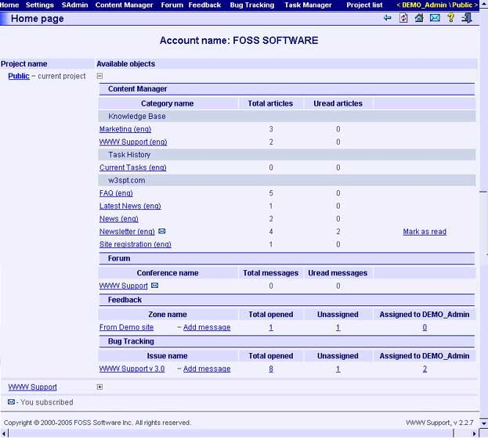

Fields and tables
"Projects" table
The "Projects" table shows you a list of all projects which are allowed for the current user. Clicking the "+" button in the right column will expand all objects allowed for current user. You can make a project active by clicking it or using "Projects" menu. The active project shows with bold font and "Current project" label in project list.

System menu
The system menu is part of the interface on every page in the system. It is used for navigation through the system and as an indication of main system parameters.

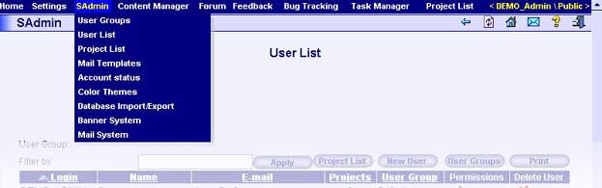

Navigation
All functionality of WWW Support system is available through the system menu. The system generates the menu structure dynamically depending on the user’s permissions. The following list displays the system menu structure and contains a brief description for each item.
Home
This menu item is used to return to the Main page of WWW Support system.
The item is allowed for all users.
Logout
Use this item to logout from WWW Support system.
The item is allowed for all users.
Settings
Settings menu contains the common functions.
The item is allowed for all users.
User Profile
The "User Profile" menu item opens the "User profile: [user]" page which is used to set/view user options. The item is allowed for all users.
Make Page as Default
Use this menu item to set current page as default page. Next time you enter the system default page will be shown just after system login page.
The item is allowed for all users.
SAdmin
Use this menu item to get access to the common administration tools such as users and projects administration, message templates, statistics, etc.
The item is allowed for users with roles System Administrator and Administrator.
User Groups
The "User Groups" menu item opens the "SAdmin: User Groups" page which is used to view/manage user groups.
User List
The "Users list" menu item opens the "SAdmin: User list" page which is used for viewing the user list.
Project List
The "Project List" menu item opens the "SAdmin: Project List" page which is used to view/manage projects list.
Mail Templates
The "Mail Templates" menu item opens the "SAdmin: Mail Templates: Template Configuration" page which is used for administration of mail templates.
The item is allowed for users with roles System Administrator and Administrator.
Account Status
The "Account Status" menu item opens the "SAdmin: Account Status: [account]" page which is used for viewing account statistics.
The item is allowed for users with roles System Administrator and Administrator.
Color Themes
The "Color Themes" menu item opens the "SAdmin: Color Themes: Color Themes List" page which is used for administration of interface color schemes.
The item is allowed for users with roles System Administrator and Administrator.
Database Export
The "Database export" menu item opens the "SAdmin: Database Export" page which is used for exporting data of the system objects.
The item is allowed for users with roles System Administrator and Administrator.
Database Import
The "Database Import" menu item opens the "SAdmin: Database Import" page which is used for importing data of the system objects.
The item is allowed for users with roles System Administrator and Administrator.
Banner System
The item has two subitems: "Banner List" and "Banner Settings".
Banner List
The "Banner List" menu item opens the "SAdmin: Banner System: Banner List" page which is used for viewing banner list.
Banner Settings
The "Banner Setting" menu item opens the "SAdmin: Banner System: Banner Slot Placement" page which is used to manage banner’s slot placement for specified page groups or pages.
Mail System
The "Mail System" menu item opens the "SAdmin: Mail System" page which is used for creating and dispatching electronic messages to system users.
Content manager
Use this menu item to get access to the articles administration tools. Item contains the "Categories" item and items for all Categories created in the system. The system has three default Categories: "Knowledge Base", "News", and "FAQ" . These Categories cannot be deleted. Each Category menu item also has three subitems: "Themes List", "Search" and "Subscription".
The item is allowed for authorized users.
Categories
The "Categories" menu item opens the "Content Manager: Categories" page which is used to manage list of categories.
The item is allowed for users with roles System Administrator and Administrator.
"[Category name]" menu item
The item has three subitems: "Themes List", "Search" and "Subscription".
The item is allowed for authorized users.
Theme List
The "Theme List" menu item opens the "Content Manager: [category]: Theme List" page which is used to manage themes list of specified articles.
Search
The "Search" menu item opens the "Content Manager: [category]: Search" page which is used to find the articles.
Subscription
The "Subscription" menu item opens the "Content Manager: [category]: Subscription" page which is used to manage subscription.
Forum
Use this menu item to get access to the Forum subsystem administration tools.
The item is allowed for authorized users.
Forum List
The "Forum List" menu item opens the "Forum: Forum List" page which is used to manage forums. The item also contains sub items with the names of forums which are allowed for the current user. You can open the "Forum: Message List: [forum]" page by clicking the menu item of the same name.
Subscription
The "Subscription" menu item opens the "Forum: Subscription" page which is used to manage forum subscriptions.
Feedback
Use this menu item to get access to the Feedback subsystem administration tools.
The item is allowed for authorized users.
Zone List
The "Zone List" menu item opens the "Feedback: Zone list" page which is used to manage zones. The item also contains sub items the name of zones which are allowed to current user. You can open the "Feedback: Message List: [zone]" page by clicking the menu item of the same name.
Configuration
The "Configuration" menu item opens the "Feedback: Configuration" page which is used to manage message and message status types.
The item is allowed for System Administrator and Administrator.
Subscription
The "Subscription" menu item opens the "Feedback: Subscription" page which is used to manage subscriptions.
Statistics
The item contains links to statistics tools.
Activity Report
The "Activity Report" menu item opens the "Feedback: Activity Report" page which is used for viewing common activity statistics.
The item is allowed for the authorized user.
User Activity
The "User Activity" menu item opens the "Feedback: User Activity Report" page which is used for viewing activity statistics of specified user.
The item is allowed for the authorized user.
Bug Tracking
Use this menu item to get access to the Bug Tracking subsystem administration tools.
The item is allowed for authorized users.
Issue List
The "Zones" menu item opens the "Bug Tracking: Issue list" page which is used to manage problems. The item also contains sub items with the same name of problems which are allowed to current user. You can open the "Bug Tracking: Message List: [issue]" page by clicking the menu item of the same name.
Configuration
The "Configuration" menu item opens the "Bug Tracking: Configuration" page which is used to manage message and message status types.
The item is allowed for System Administrator and Administrator.
Subscription
The "Subscription" menu item opens the "Bug Tracking: Subscription" page which is used to manage subscriptions.
Statistics
Activity Report
The "Activity Report" menu item opens the "Bug Tracking: Activity Report" page which is used for viewing common activity statistics.
The item is allowed for the authorized user.
Users’ Activity
The "Users’ Activity" menu item opens the "Bug Tracking: Users’ Activity Report" page which is used for viewing activity statistics of specified user.
The item is allowed for the authorized user.
Task manager
Use this menu item to get access to the Task Management administration tools.
The item is allowed for authorized users.
Task List
The "Task List" menu item opens the "Task Manager: Task list" page which is used to manage project tasks.
The item is allowed for the authorized user.
Permissions
The "Permissions" menu item opens the "Task Manager: Edit Permissions: Task Access Permissions" page which is used for administration of users’ permissions within tasks for the current project.
The item is allowed for the authorized user.
Statistics
The "Statistics" menu item opens the "Task Manager: Task statistics" page which is used for viewing of common task statistics.
Projects List
The "Project List" menu contains links to the projects which are allowed for the current user. You can set the active project by clicking the corresponding menu item. Information about the selected project is shown on the right side of the main menu.

Indication of system parameters
Immediately after login, on the right side of the system menu, you will see an item which says "To start – select a project from menu". After selecting a project it becomes the active project, and is displayed here, along with the name of the current user.

"Administration" subsystem

"User Profile: [user]" page
Use this page for viewing or editing user’s options and information.

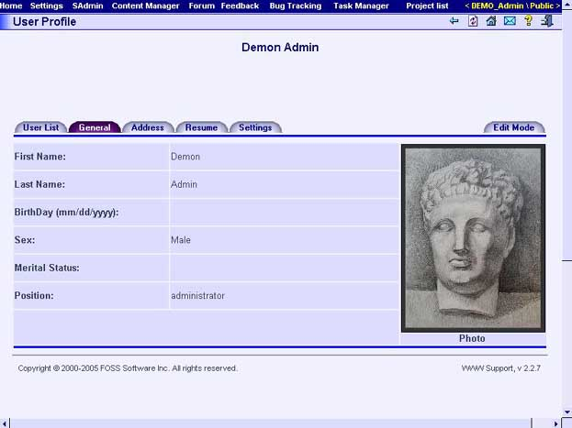

Buttons
User List
Opens the "SAdmin: User List" page.
General
Shows the common information about the user.
Address
Shows the address information of the user.
Resume
Shows the resume of the user.
Settings
Shows user’s options.
Edit/View mode
Toggles between view and edit mode.
Update Photo
Shows the page for changing user’s photo.
Update
Saves entered changes.
Change Password
Shows the page for changing user’s password.

"SAdmin: User Groups" page
This page shows the list of user groups. Information about user groups is shown in the table containing one row for each user group.

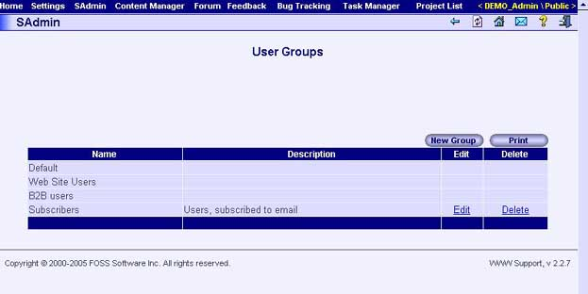

User Groups Table Columns
Name
Name of the user group.
Description
Description of the user group.
Edit
Use this link to edit name and description of the user group.
Delete
Use this link to remove a user group from the system.

Buttons
New Group
Use this button to create a user group in the system.
Print
Opens print version of the current page.

"SAdmin: User List" page
This page shows the list of system users. Information about users is shown in the table containing one row for each user.

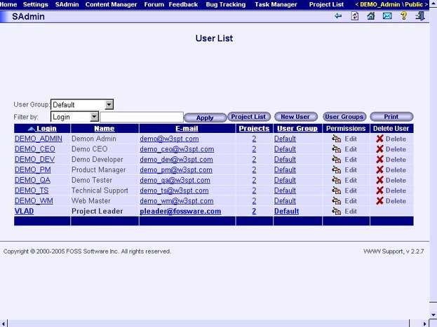

User List Table Columns
Login
User’s login. This field is implemented as a hyperlink to the "User Profile: [user]" page.
Name
Name and surname of the user.
E-mail
User’s e-mail address - implemented as a hyperlink which will launch your mail application.
Projects
Number of projects which the user is a member - implemented as a hyperlink to the "SAdmin: User Roles: [user]" page".
User Group
Name of group which the user is a member - implemented as a hyperlink to the "SAdmin: Edit User Information: [user]" page".
Permissions
Link to the "SAdmin: Edit User Roles in Projects: [user]" page.
Delete User
Use this button to remove a user account from the system.

Fields
User Group
This field allows you to filter records in user list table by user’s group.
Filter by
This combo field allows filtering the users displayed in the user list table. Press "Apply" button after specifying filter to apply it. You will then see only users which contain the specified search string in the specified fields.

Buttons
Project List
Opens the "SAdmin: Project List" page.
New User
Opens the "SAdmin: Create New User" page.
User Groups
Opens the "SAdmin: User Groups" page.
Print
Opens print version of the current page.

"SAdmin: Create New User" page
Use this page to create user in system.

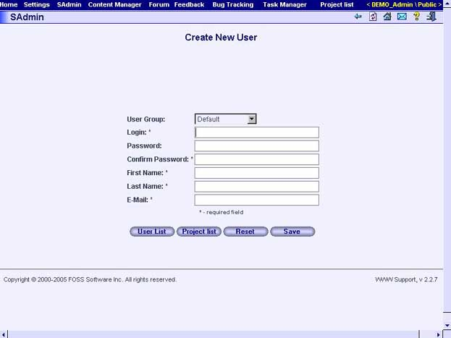

Fields
User Group
Group the user is member of.
Login
User’s login name.
Password
User’s password.
Confirm Password
User’s password. Second entry.
First Name
User’s first name.
Last Name
User’s surname.
E-mail
User’s e-mail.

Buttons
User List
Opens the "SAdmin: User List" page.
Project List
Opens the "SAdmin: Project List" page.
Reset
Clears all form fields.
Save
Creates the new user with specified properties.

"SAdmin: Edit User Information: [user]" page
Use this page to edit user information.

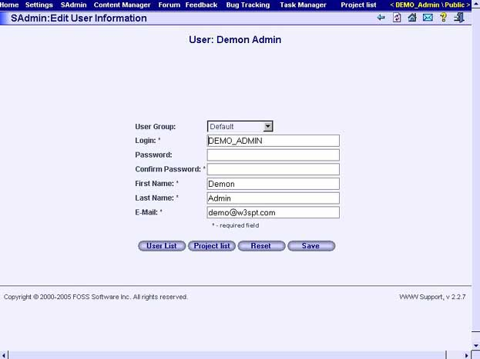

Fields
User Group
Group the user is member of.
Login
User’s login name.
Password
User’s password.
Confirm Password
User’s password. Second entry.
First Name
User’s first name.
Last Name
User’s surname.
E-mail
User’s e-mail.

Buttons
User List
Opens the "SAdmin: User List" page.
Project List
Opens the "SAdmin: Project List" page.
Reset
Clears all form fields.
Save
Creates the new user with specified properties.

"SAdmin: User Roles: [user]" page
Use this page to view user participation in projects. The user’s name is shown as the name of the page. Information about the user’s projects is shown in the "Project List" table which contains one row for each project.

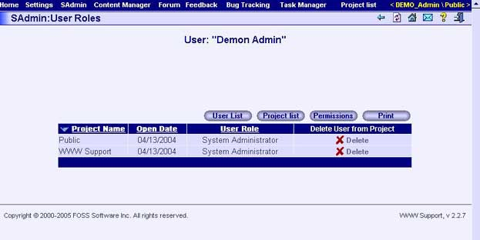

Project List Table Columns
Project Name
Name of project the user is participates in.
Open Date
Date the project was created.
User Role
User’s role in project, which will determine permissions.
Delete User from Project
User this link to delete a user from the project.

Buttons
User List
Opens the "SAdmin: User List" page.
Project List
Opens the "SAdmin: Project List" page.
Permissions
Opens the "SAdmin: Edit User Roles in Projects: [user]" page for current user.
Print
Opens view only version of the current page.

"SAdmin: Edit User Roles in Projects: [user]" page
Use this page to manage the user’s permissions to projects. The user’s name is shown as the name of the page. Information about user’s permission to projects is shown in the "Project List" table containing one row for each project.

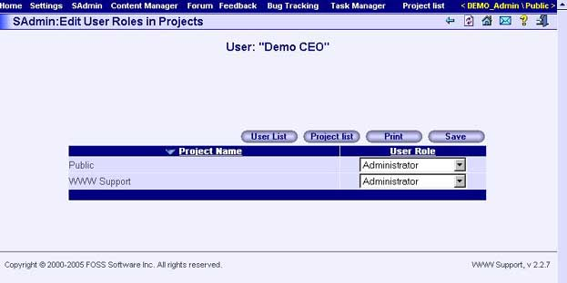

Project List Table Columns
Project Name
Name of project the user is a participant in.
User Role
User’s role in project, which will determine permissions.

Buttons
User List
Opens the "SAdmin: User List" page.
Project List
Opens the "SAdmin: Project List" page.
Print
Opens the view only version of the current page.
Save
Saves all changes.

"SAdmin: Project List" page
Use this page to view/change system projects list. Information about projects is shown in the "Project List" table containing one row for each project.

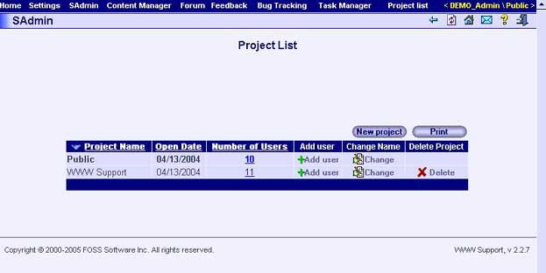

Project List Table Columns
Project Name
Name of project the user is participator of.
Open Date
Project creation date.
Number of Users
Number of project participants - implemented as a hyperlink to the "SAdmin: Project Users: [project]" page.
Add User
Column "Add User" contains the "Add User" button. Use this button to add users to the project.
Change Name
Column "Change Name" contains the "Change" button. Use this button to rename project.
Delete Project
Column "Delete" contain the "Delete" button. Use this button to remove project from the system.

Buttons
New Project
Use this button to add a new project to the system. After pressing the button enter the name of the new project in the window.
Print
Opens view only version of the current page.

"SAdmin: Project Users: [project]" page
Use this page to view/change a user’s participation in a project. The project name is shown as the name of the page.

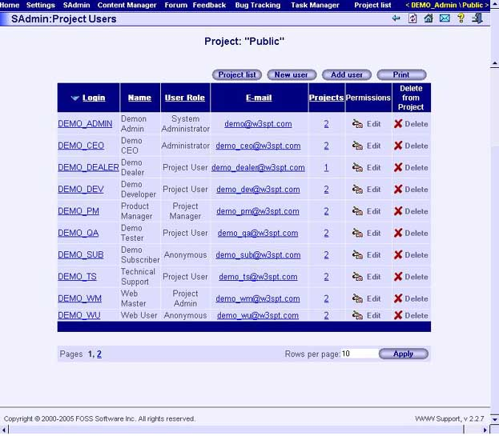

User List Table Columns
Login
User’s login name.
Name
Name and surname of the user.
User Role
User’s role in project, which will determine permissions.
E-mail
User’s e-mail address - implemented as a hyperlink which will launch your mail application.
Projects
Number of users of project - implemented as a hyperlink to the "SAdmin: User Roles: [user]" page.
Permissions
Implemented as "Edit" button. Pressing this button you can go to the "SAdmin: Edit User Roles in Projects: [user]" page.
Delete from Project
Link which can be used to remove a user account from the project.

Buttons
Projects List
Opens the "SAdmin: Project List" page.
New User
Opens the "SAdmin: Create New User" page.
Add User
Opens the "SAdmin: Adding User to Project: [project]" page
Print
Opens the view only version of the current page.

"SAdmin: Adding User to Project: [project]"
Use this page to add users in project. The project name is shown as the name of the page.

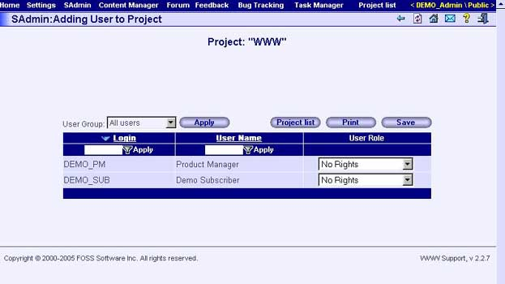

User List Table Columns
Login
User’s login name.
User Name
Name and surname of the user.
User Role
Role the user is member of.

Fields
User Group
This combo box allows you to filter records in Users List Table by user’s group. After choosing group press "Apply" button to apply filter.

Buttons
Project List

Opens the "SAdmin: Project List" page.
Print
Opens print version of the current page.
Save
Saves all changes.

"SAdmin: Mail Templates: Template Configuration" page
Use this page to view and manage mail templates.

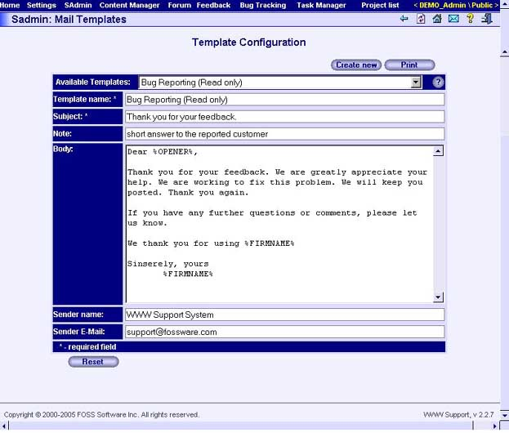

Fields
Available Templates
This is the list of mail templates which are already available in the system. Choose required template to fill fields. You can then edit template properties.
Template Name
Name of the selected template.
Subject
Subject of the mail template.
Note
Brief description of the template’s use.
Body
Text of the mail template.
Sender name
Name of letter sender.
Sender e-mail
E-mail of letter sender.

Buttons
Create New
Creates new template. To create template enter name of the new template in the window.
Print
Opens view only version of the current page.
Reset
Reset all values.

"SAdmin: Account Status: [account]" page
Use this page to view various statistics about a company’s account. The account name is shown as the name of the page. On the page is information about objects, subscription, and subscription history.

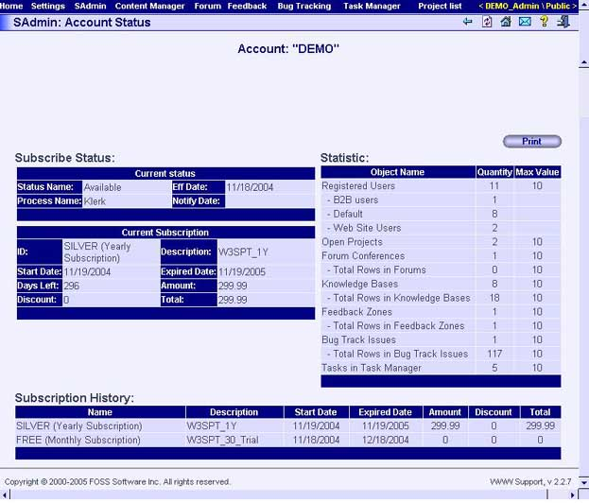

Buttons
Print
Opens print version of the current page.

"SAdmin: Color Themes: Color Themes List" page
Use this page to manage system appearance. Information about color themes is shown in the table containing one theme per row.

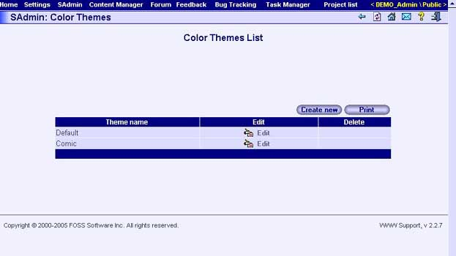

Themes table columns
Theme name
Name of the color theme.
Edit
Clicking this link will bring you to the "SAdmin: Color Themes: Color Theme Configuration" page.
Delete
Use the delete button to remove the color theme from the system.

Buttons
Create New
Used to create a new color theme.
Print
Opens print version of the current page.

"SAdmin: Color Themes: Color Theme Configuration" page
Using this page you can edit properties of a color theme.

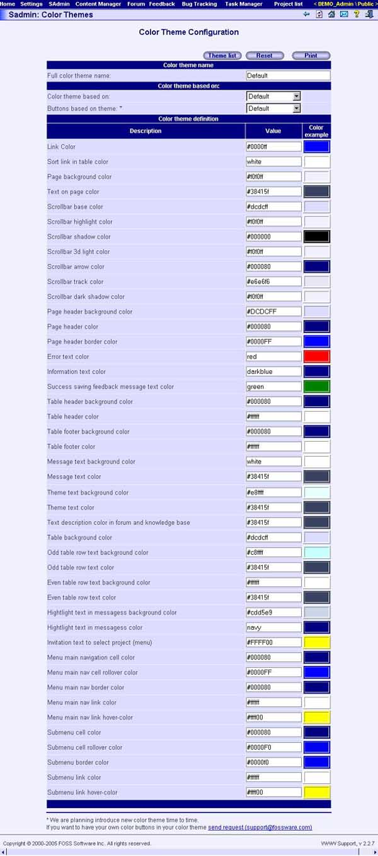

Fields
Color Theme Name
Name of the new or edited color theme.
Color Theme is Based on
Name of theme which new theme is based.
Color Theme Definition
The set of fields which determine the theme.

Buttons
Theme List
Shows the "SAdmin: Color Themes: Color Themes List" page.
Reset
Clears all form fields.
Print
Opens view only version of the current page.

"SAdmin: Database Export" page
Use this page to export data from the system. To export data, first choose system object in the table from which you want export data, then press the "Export" button and download the export file with data to your location.

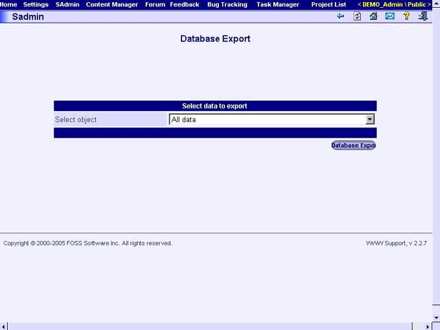

"SAdmin: Database Import" page
Use this page to import data to the system. To import data, choose previously created file with exported data and then press the "Upload" button. Information from the file will be imported to the system database.

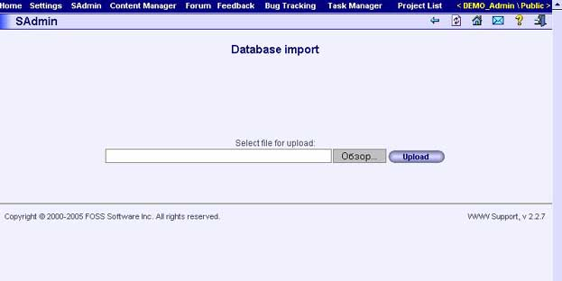

"SAdmin: Banner System: Banners List" page
Use this page to manage banners list. The page displays information about available banners in the table which contains one row for each banner.

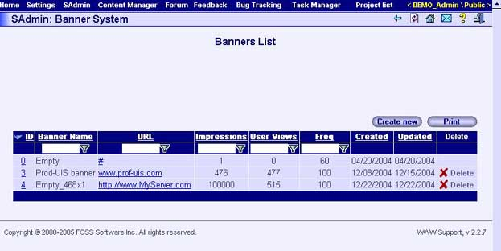

Table Columns
ID
ID of the banner. Text of column implemented as hyperlink to the "SAdmin: Banner System: Banner Information" page which displays corresponding banner information.
Banner Name
Name of the banner.
URL
URL of the banner.
Impressions
How many times the banner will be displayed to visitors.
User Views
How many times the banner has been viewed..
Freq
Frequency of display of the banner related to other banners in same banner slot and on same page.
Created
Banner creation date.
Updated
Banner information update date.
Delete
The column contains the "Delete" button. By pressing this button you can delete a banner from the system.

Buttons
Create New
Opens the "SAdmin: Banner System: Banner Information" page where you can create a new banner.
Print
Opens print version of the current page.

"SAdmin: Banner System: Banner Information" page
Use this page to create/view the banner.

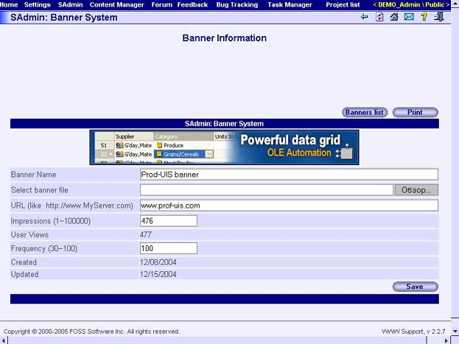

Fields
Banner Name
Name of the banner.
Select banner file
Select banner file for uploading to the system.
URL
URL of the banner.

Impressions
How many times the banner will be displayed to visitors.
User Views
How many times the banner has been viewed..
Frequency
Frequency of display of the banner related to other banners in same banner slot and on same page.
Created
Banner creation date.
Updated
Banner information update date.

Buttons
Banners List

Opens the "SAdmin: Banner System: Banners List" page.
Print
Opens print version of the page.
Save
Save banner information.

"SAdmin: Banner System: Banner Slot Placement" page
Use this page to manage banner’s slot placement for specified page groups or pages.

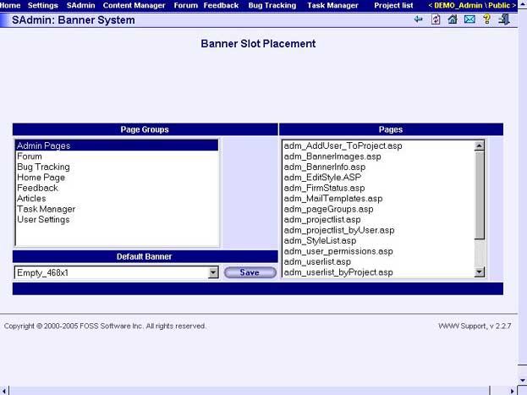

Fields
Page Groups
Page groups list.
Pages
Pages in group.
Default Banner
Banner name for chosen page group.

Buttons
Save
Save banner slot settings.

"SAdmin: Mail System: Mail List" page
This page provide possibility create and send email messages to the account users.

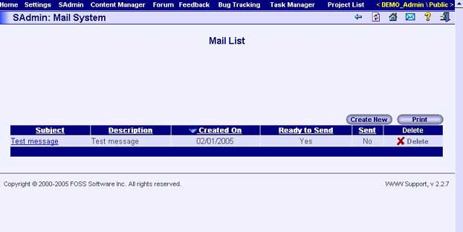

Table columns
Subject
Subject of the message. implemented as a hyperlink to the "SAdmin: Mail System: Edit E-Mail" page.
Description
The additional description (it is not included to sent message).
Created On
Message creation date
Ready to Send
Shows that the message is ready
Sent
Shows that the message has been sent
Delete
Used to delete the message

Buttons
Create New
Creates new message
Print
Opens print version of the message

"SAdmin: Mail System: Compose New E-Mail" page
Used to create new Email.

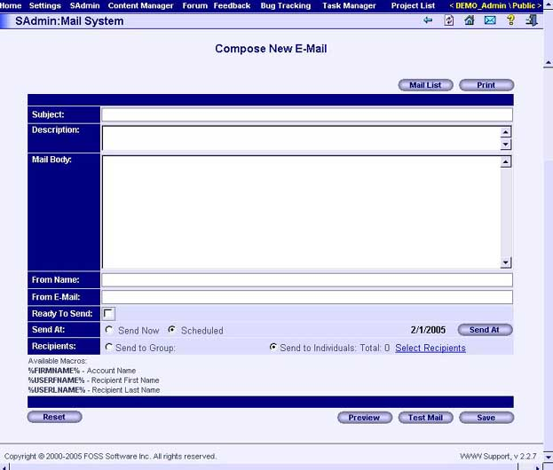
Required fields: "Subject", "Mail Body", "From Name" and "From E-Mail"
Fields "Subject" and "Mail Body" can contain following macros:
- %FIRMNAME% - the name of an account from which occurs dispatch of the letter;
- %USERFNAME% - a name of the addressee;
- %USERLNAME% - a surname of the addressee.

Fields
Subject
Subject of the message.
Description
Brief description of the message (not included to sent message).
Mail Body
Body of the message in HTML format
From Name
Sender name
From E-Mail
Sender E-Mail address
Ready to Send
Shows that the message is ready to send.
Send At
Shows when the letter should be sent. Valid vlues: "Send now" - the message will be sent immediately, "Scheduled" - date when the message will be sent
Recipients
Shows number of recipients. "Select Recipients" link allows review and modify the list. This link opens "SAdmin: Mail System: Mail Recipients" page.

Buttons
Mail List
Opens the "SAdmin: Mail System: Mail List" page.
Print
Opens print version of the message
Reset
Clears form
Preview
Previews the message in a new window.
Test Mail
The message will be send to the user.
Save
Saves the message.

"SAdmin: Mail System: Edit E-Mail" page
The page used to edit the message information. All fields same with "SAdmin: Mail System: Compose New E-Mail" page.

"SAdmin: Mail System: Mail Recipients" page
The page used to select recipients from users list. Press "Save" button when the recipients list will be ready.

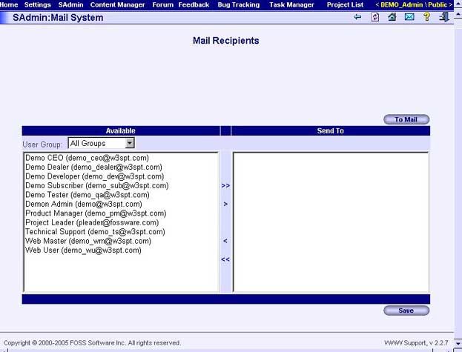

"Content Manager" subsystem

"Content Manager: Categories" page
Use this page to manage article types in the Content Manger subsystem. Information about categories is shown in the table containing one theme per row. You can change or delete any article categories except predefined types such as "Knowledge Base", "News", and "FAQ".

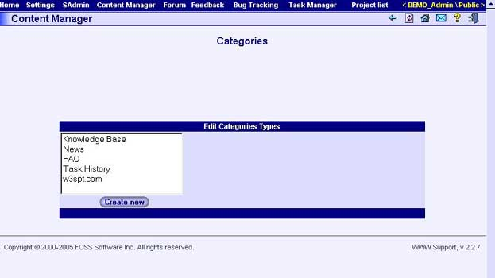

Buttons
Create New
Creates new Category.

"Content Manager: [category]: Theme List" page
Use this page to manage theme list of the category.

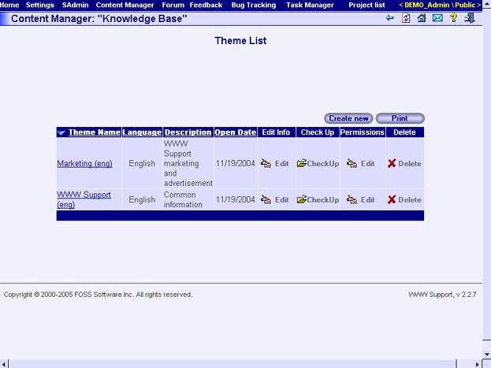

Table columns
Theme Name
Name of the article theme. This field is implemented as a hyperlink to the "Content Manager: [category]: [theme]: Article List" page.
Language
Language of the theme articles
Description
Brief description of the theme
Open Date
Theme creation date
Edit Info
This column contains the "Edit" button. Press this button to edit information about the corresponding theme.
Check Up
This column contains the "Check Up" button. Press this button to test the appearance of the theme. After pressing this button you can see the list theme articles.
Permissions
This column contains the "Edit" button. Press this button to change a user’s permissions to the theme.
Delete
Deletes the theme

Buttons
Create New
Creates a new theme
Print
Opens ready to print version of the current page.

"Content Manager: [category]: Create New Theme" page
Use this page to create the theme information.

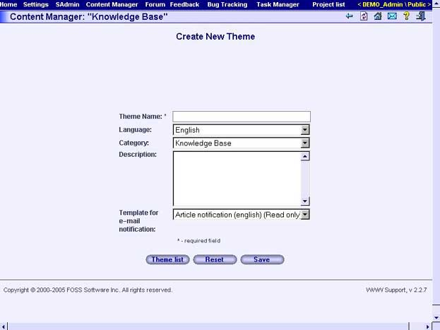

Fields
Theme name
The name of a theme.
Language
Language on which publications are mainly written.
Category
The list of categories from which you can choose necessary.
Description
The brief description of a theme.
Template for e-mail notification
The list of templates from which you can choose necessary.

Buttons
Theme List

Opens the "Content Manager: [category]: Theme List" page.
Reset
Clear fields of the form of the entered information.
Save
Create a new theme.

"Content Manager: [category]: Edit Theme Information: [theme]" page
Use this page to edit the theme information.

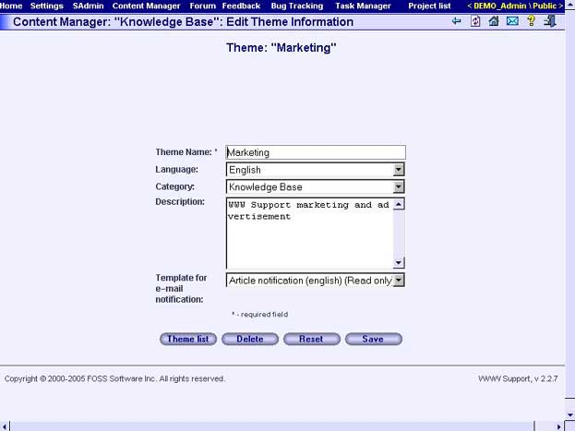

Fields
Theme name
Name of the theme.
Language
Theme language.
Category
Theme category.
Description
The brief description of a theme.
Template for e-mail notification
The list of templates for user notification about new articles in the theme. Select one for the theme.

Buttons
Theme List

Opens the "Content Manager: [category]: Theme List" page.
Delete
Delete theme.
Reset
Clear fields of the form of the entered information.
Save
Save information.

"Content Manager: [category]: Edit Permissions: [theme]" page
Use this page to change user rights for the theme.

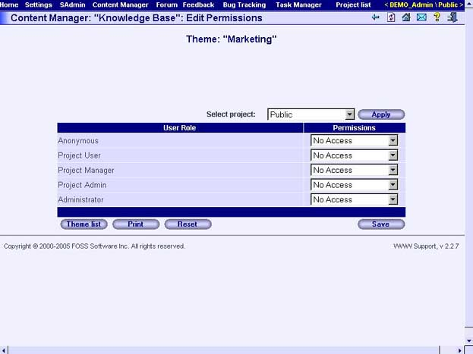

Fields
Select project
Projects list.

Table columns
User Role
User roles list.
Permissions
The list of user rights for the theme.

Buttons
Themes List

Opens the "Content Manager: [category]: Theme List" page
Print
Opens print version of the current page.
Reset
Clears all form fields.
Save
Save permissions set.

"Content Manager: [category]: Articles List: [theme]" page
Use this page to view the list of theme articles. The theme name is shown as the name of the page. This page contains a table with a list of theme articles. Each row contains a hyperlink to the corresponding "Content Manager: [category]: [theme]: Article Detail" page which shows content of the article.
Please note, that all published theme articles are displayed using regular font.
Non-published theme articles are displayed using italic font.
This feature is discussed on WWW SUPPORT User's Guide at Using "Content Manager", "Articles formatting" topic.

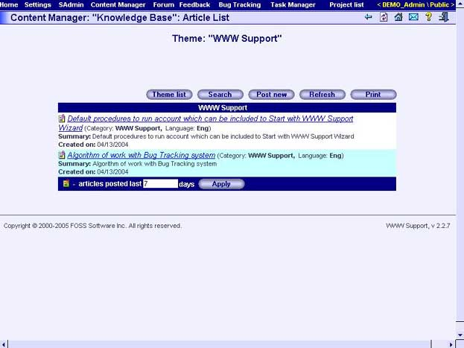

Fields
"Articles posted last _ _ days"
Period in days. During this period an article is considered new. New article is highlighted in the articles list.

Buttons
Themes List
Opens the "Content Manager: [category]: Theme List" page.
Search
Opens the "Content Manager: [category ]: Search" page to search for an article.
Post New
Opens the Content Manager: [category ]: [theme]: Create New Article" page.

Refresh
Refresh the page.

Print
Opens "print ready" version of the current page.

"Content Manager: [category]: [theme]: Create New Article" page
Use this page to create a new article in a theme.

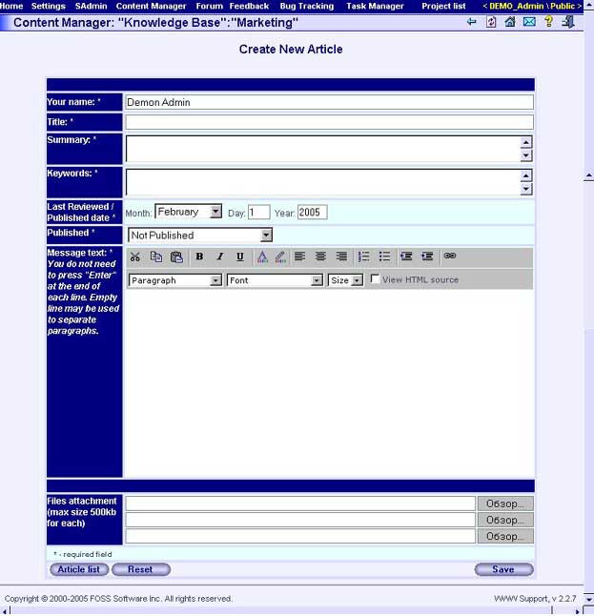

Fields
Your Name
An author name
Title
The article title Article title can contain up to 1000 symbols.
Summary
Summary of the article. Article summary can contain up to 1000 symbols.
Keywords
Keywords of the article. Keywords field can contain up to 1000 symbols. A keywords field contains words which are used during article search. The keywords are separated by space.
Last Reviewed / Published date
Last Reviewed / Published date.
Published
This field can contain the following values: "Published", "Publish at the published date" and "Not Published".
Message text
Text of article.
Files attachment
Attached files – every article can have up to 3 attachments with size no more than 500K each.

Buttons
Article List
Opens the "Content Manager: [category]: Articles List: [theme]" page.
Reset
Clears all form fields.
Save
Saves a new article.

"Content Manager: [category]: [theme]: Edit Article" page
Use this page to edit the article.

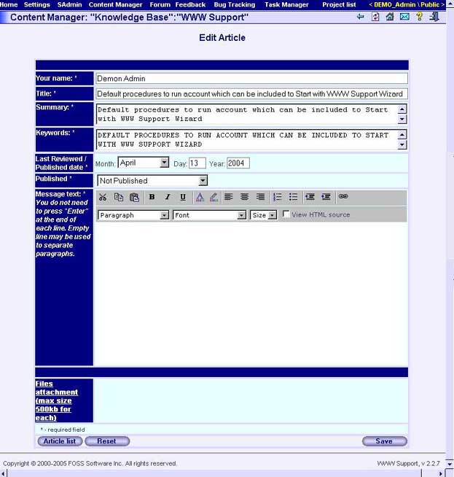

Fields
Your Name
An author name
Title
The article title. Article title can contain up to 1000 symbols.
Summary
Summary of the article. Article summary can contain up to 1000 symbols.
Keywords
Keywords of the article. Keywords field can contain up to 1000 symbols. A keywords field contains words which are used during article search. The keywords are separated by space.
Last Reviewed / Published date
Last Reviewed / Published date.
Published
This field can contain the following values: "Published", "Publish at the published date" and "Not Published".
Message text
Text of article.
Files attachment
Attached files – every article can have up to 3 attachments with size no more than 500K each.

Buttons
Article List
Opens the "Content Manager: [category]: Articles List: [theme]" page.
Reset
Clears all form fields.
Save
Saves a new article.

"Content Manager: [category]: [theme]: Article detail" page
Use this page to view the contents of an article. Information about the article is placed in the table.

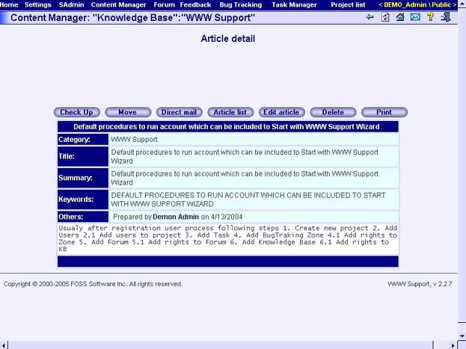

Buttons
Check Up
Pressing this button you can test the appearance of the article. After pressing this button you can see the article in the new window.
Move
Pressing this button you can move/copy the article to other theme. After pressing this button you can see new window "Article moving/coping".
Direct mail
Pressing this button you can send the article using direct mail.
Article List
Opens the "Content Manager: [category]: Articles List: [theme]" page.
Edit Article
Opens the "Content Manager: [category]: [theme]: Edit Article" page.
Delete
Deletes displayed article.
Print
Opens view only version of the current page.

"Content Manager: [category]: Search" page
Use this page to search articles. Fill required fields and press the "Search" button. The results are displayed under the search form in the table. Each row of the table contains a hyperlink to the article.

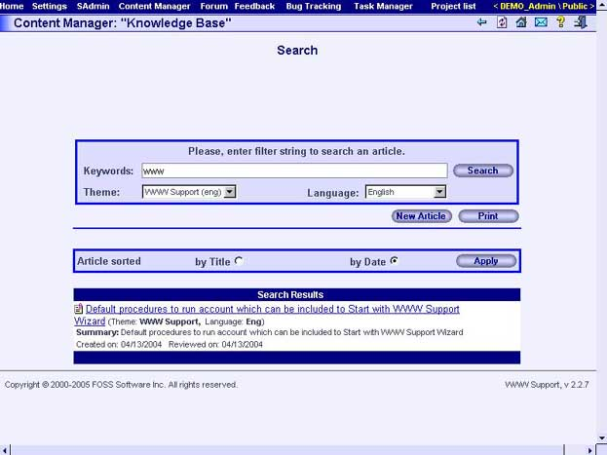

Fields
Keywords
Keywords separated by spaces. Keywords are used for article search.
Theme
Theme of the sought article.
Language
Language of the sought article.

Buttons
Search
Starts the article search.
Print
Opens a view only version of the current page.

"Content Manager: [category]: Subscription" page
Use this page to manage subscription to the articles in the specified article type. Information about subscription is displayed in the table which contains one row for each theme.

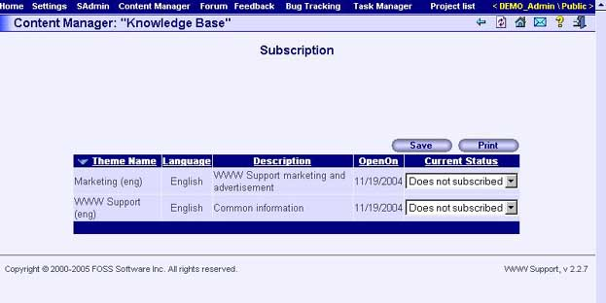

Theme subscription table columns
Theme name
Name of the theme.
Language
Language of the theme.
Description
Brief description of the theme.
OpenOn
Theme creation date.
Current Status
This combo box contains the list of all subscription modes. Use this combo to mange subscription to the theme.

Buttons
Save
Saves changes.
Print
Opens the view only version of the current page.

"Forum" subsystem

"Forum: Forum List" page
Use this page to view or manage forums. Information about forums is displayed in the table which contains one row for each conference.

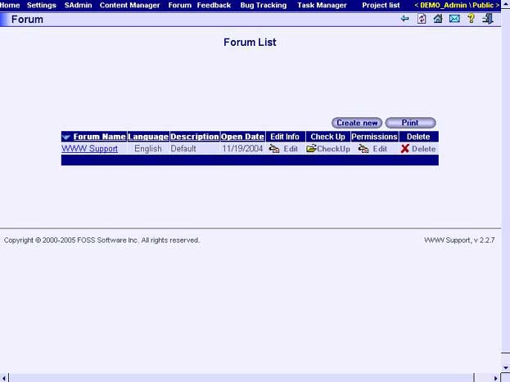

Forum List Table Columns
Forum Name
Name of the forum – implemented as hyperlink to the "Forum: Message List: [forum]" page which displays information about corresponding forum.
Language
Language of the forum.
Description
Brief information about the forum.
Open Date
Forum creation date.
Edit Info
Column contains the "Edit" button. Pressing the "Edit" button will open the "Forum: Edit Forum Information: [forum]" page displaying information about the corresponding forum.
Check Up
The column contains the "Check Up" button which allows testing forum appearance in a new window containing list of the forum messages.
Permissions
The column contains the "Edit" button which allows managing users’ permissions to the corresponding forum. Pressing this button you open the "Forum: Edit Permissions: [forum]" page.
Delete
Deletes corresponding forum.

Buttons
Create New
Opens the "Forum: Create New Forum" page which allows creation of new forum.
Print
Opens the print version of the current page.

"Forum: Create New Forum" page
Use this page to create the new forum.

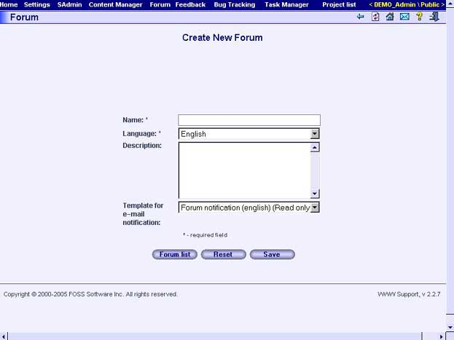

Fields
Name
Forum name.
Language
Language of the forum.
Description
Brief description of the forum.
Template for e-mail notification
Template for forum subscription message.

Buttons
Forum List
Shows the "Forum: Forum List" page.
Reset
Clears all form fields.
Save
Creates a new forum.

"Forum: Edit Forum Information: [forum]" page
Use this page to edit forum properties. The forum name is shown in the page title.

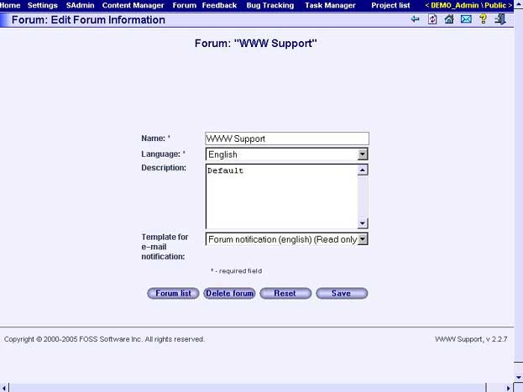

Fields
Name
Forum name.
Language
Language of the forum.
Description
Brief description of the forum.
Template for e-mail notification
Template for forum subscription message.

Buttons
Forum List
Shows the "Forum: Forum List" page.
Delete forum
Deletes the forum.
Reset
Clears all form fields.
Save
Saves forum properties.

"Forum: Edit Permissions: [forum]" page
Use this page to manage users’ permissions to the forum. The name of the selected forum is shown in the page title. Information about users’ permissions is displayed in the table which contains one row for each user’s role.

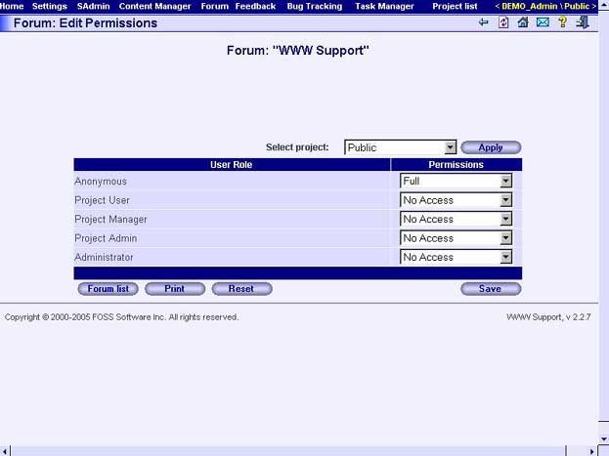

Table Columns
User Role
Name of the user’s role.
Permissions
The list of group permissions.

Fields
Select project
Combo which contains the list of projects. Choose the project to which you want to assign permissions.

Buttons
Forum List
Opens the "Forum: Forum List" page.
Print
Opens print version of the current page.
Reset
Clears all form fields.
Save
Saves forum properties.

"Forum: Message List: [forum]" page
Use this page to view messages tree and particular messages of a forum. The name of the forum is shown in the page title. The page is divided into parts. The top part displays the messages tree. The bottom part displays the particular message which is selected in the message tree.

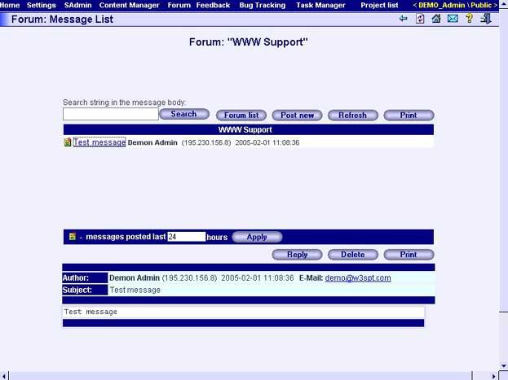

Message tree table columns
Message subject
Subject of forum message.
User name
Name of the message creator.
IP address
IP address of the creator’s computer.
Date and time
Date and time of message creation.

Fields
Search string in the message body
This field allows filtering the messages displayed in the message list table. Press "Search" button after specifying filter to apply it. You will then see only messages which contain the specified search string.

Buttons
Forum List
Opens the "Forum: Forum List" page.
Post New
Opens the "Forum: [forum]: Create New Message" page with purpose of creation of new message.
Refresh
Refresh page.
Print
Opens print version of the current page

"Forum: [forum]: Create New Message" page
Use this page to create new message. If this page is used to reply to a message the original is shown at the bottom of the page.

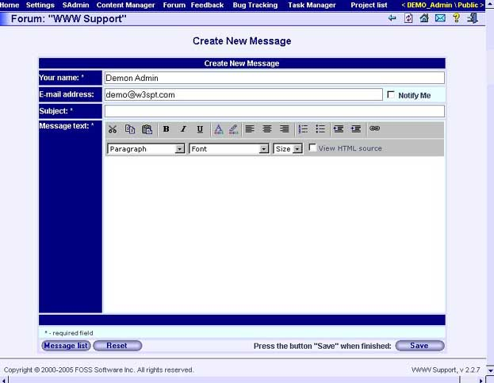

Fields
Your Name
This field contains your name by default.
E-mail address
This field contains your e-mail address by default.
Notify me
If you check this checkbox you will receive the reply messages in your e-mail.
Subject
Subject of the message.
Message Text
Text of your message.

Buttons
Save
Saves new message properties.
Message List
Opens the "Forum: Message List: [forum]" page.
Reset
Clears all form fields.

"Forum: Subscription" page
Use this page to manage your subscription to the forums. Information about subscription is displayed in the table which contains one row for each forum.

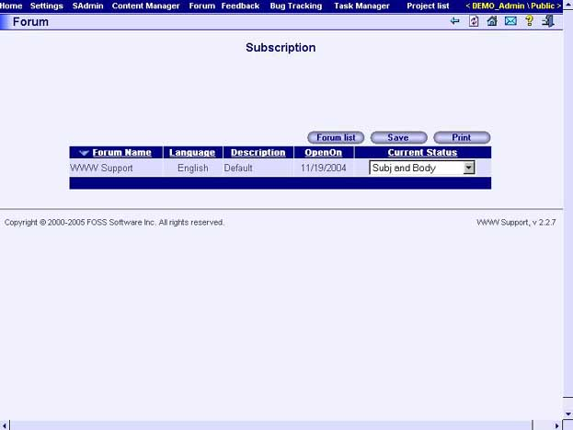

Table Columns
Forum Name
Name of the forum.
Language
Forum language.
Description
Brief description of the forum.
OpenOn
Forum creation date.
Current Status
Combo box contains the list of available subscription types. Choose the subscription type you need.

Buttons
Forum List
Shows the "Forum: Forum List" page.
Save
Saves subscription settings.
Print
Opens print version of the current page.

"Feedback" subsystem

"Feedback: Zone List" page
Use this page to manage feedback zones. The page displays information about available feedback zones in the table which contains one row for each zone.

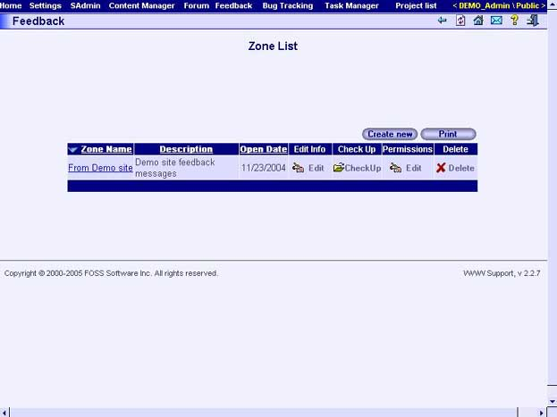

Table Columns
Zone Name
Name of the zone.
Description
Brief description of the zone.
Open Date
Zone creation date.
Edit Info
This column contains the "Edit" button - which will open the "Feedback: Edit Zone Information: [zone]" page.
Check Up
The column contains the "Check Up" button. Pressing this button opens the "Feedback: Message List: [zone]" page there you can test a zone appearance.
Permissions
The column contains the "Edit" button. Pressing this button opens the "Feedback: Edit Permissions: [zone]" page where you can configure users’ permissions.
Delete
The column contains the "Delete" button. Pressing this button you delete corresponding feedback zone.

Buttons
Create New
Opens the "Feedback: Create New Zone" page to create a new zone.
Print
Opens print version of the current page.

"Feedback: Create New Zone" page
Use this page to create new feedback zone.

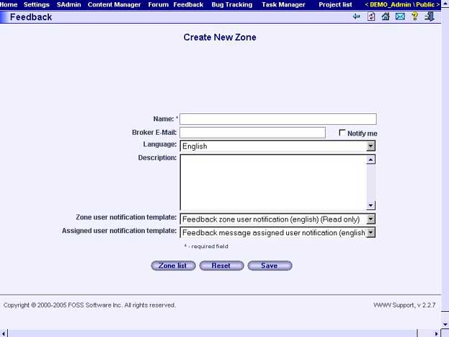

Fields
Name
Name of new zone.
Broker E-mail
E-mail of zone responsible person.
Notify me
When checked, the zone’s responsible person will receive notifications about new zone message.
Language
Language of the zone.
Description
Brief description of zone purpose.
Zone user notification template
Mail template used for notification to users about new message in zone.
Assigned user notification template
Mail template used for notification to users about new message assigned to him in zone.

Buttons
Zone List
Opens the "Feedback: Zone List" page.
Reset
Clears all form fields.
Save
Creates new zone.

"Feedback: Edit Zone Information: [zone]" page
Use this page to manage zone properties. Name of the zone is displayed in the title of the page.

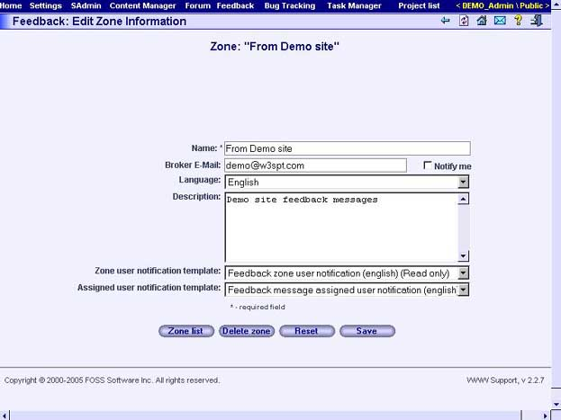

Fields
Name
Name of zone.
Broker E-mail
E-mail of zone responsible person.
Notify me
If checkbox is checked zone responsible person will receive notifications of new zone messages.
Language
Language of the zone.
Description
Brief description of zone’s purpose.
Zone user notification template
Mail template used for notification to users about new message in zone.
Assigned user notification template
Mail template used for notification to users about new message assigned to him in zone.

Buttons
Zone List
Opens the "Feedback: Zone List" page.
Delete zone
Deletes the zone.
Reset
Clears all form fields.
Save
Saves zone properties.

"Feedback: Edit Permissions: [zone]" page
Use this page to manage users’ permissions to the certain zone. The name of selected zone is shown in the page title. Information about users’ permissions is displayed in the table which contains one row for each user’s role.

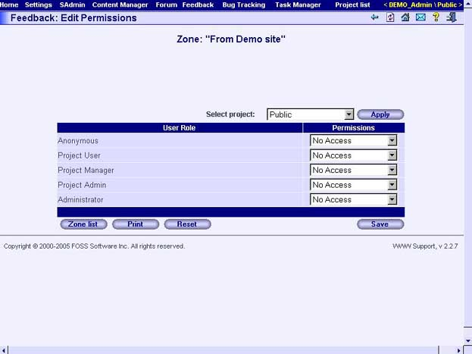

Table Columns
User Role
Name of the user role.
Permissions
The list of role’s permissions.

Fields
Select project
Combo which contains the list of projects. Choose the project for which you want to assign permissions.

Buttons
Zone List
Opens the "Feedback: Zone List" page.
Print
Opens print version of the current page.
Reset
Clears all form fields.
Save
Saves permissions information.

"Feedback: Message List: [zone]" page
Use this page to view zone feedback messages. The name of selected zone is shown in the page title. Information about zone messages is displayed in the table which contains one row for each message.

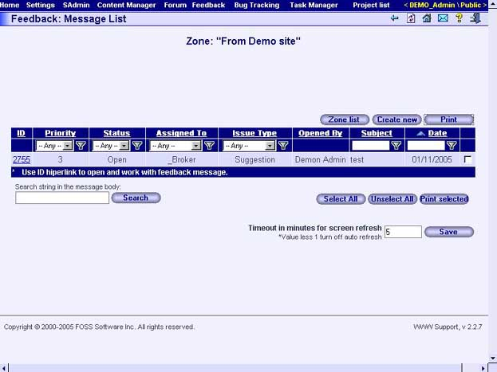

Table columns
ID
Number of messages. Text of column implemented as hyperlink to the "Feedback: [zone]: Message details" page which displays corresponding message.
Priority
Value of message priority.
Status
Status of the message.
Assigned To
Name of the zone responsible user.
Issue Type
Issue type of feedback message.
Opened By
Name of the user who has created the message.
Subject
Subject of the feedback message.
Date
Creation date of the message.
Selection column
The column contains the checkboxes for selection of messages. Selection can be used later, for example, for printing selected messages.

Fields
Search string in the message body
This field allows filtering the messages displayed in the message list table. Press "Search" button after specifying filter to apply it. You will then see only messages which contain the specified search string.
Timeout in minutes for screen refresh
Use this field for specifying automatic refresh period of the page in minutes. Press "Save" button to apply changes.

Buttons
Zone List
Opens the "Feedback: Zone List" page.
Create New
Opens the "Feedback: [zone]: Create New Message" page for creation of new message.
Print
Opens print version of the current page.
Select All
Selects all messages in the messages list table.
Unselect All
Unselects all messages in the messages list table.
Print selected
Opens page for printing of the selected messages.

"Feedback: [zone]: Create New Message" page
Use this page to create new feedback zone message.

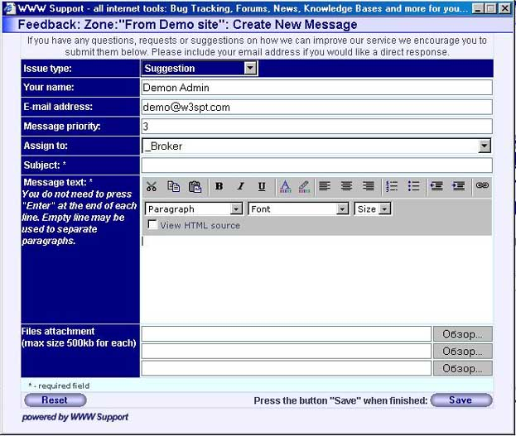

Fields
Issue type
Type of new feedback message, for example: "suggestion", "question", "code defect", etc. You can enter only predefined message types. For managing of message types list use the "Feedback: Configuration" page.
Your Name
This field contains your name by default.
E-mail address
This field contains your e-mail address by default.
Message priority
Value of message priority.
Assign to
Name of the message responsible user.
Subject
Subject of the feedback message.
Message text
Message text.
Files attachment
You can attach any 3 files which are not more than 500K each.

Buttons
Save
Creates new message.
Reset
Clears all form fields.

"Feedback: [zone]: Message details" page
Use this page to view feedback message properties.

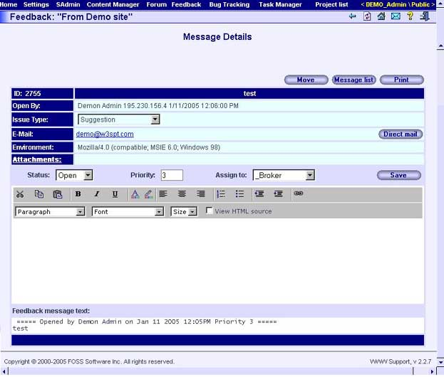

Fields
ID
Message number.
Subject
Message subject.
Open By
Name of the person who created the message.
IssueType
Message type.
E-mail
E-mail of the person who created the message.
Environment
Technical information about the user’s browser.
Attachments
Information about the attachments in the message.
Status
Message status.
Priority
Message priority.
Assign to
Name of the message responsible person.
Text
Message text.

Buttons
Previous
Shows the previous message.
Next
Shows the next message.
Move
Use this button to move the message to any zone of the "Feedback" subsystem or the "Bug Tracking" subsystem.
Message list
Opens the "Feedback: Message List: [zone]" page.
Print
Opens print version of the current page.
Save
Saves changes in the message properties.
Direct mail
Using this button to send an e-mail to the message creator. Pressing this button will bring you to the "Feedback: [zone]: Direct mail" page where you can choose a mail template, edit, and then send the e-mail.

"Feedback: [zone]: Direct Mail" page
Use this page to create and to send letters to the feedback message creator.

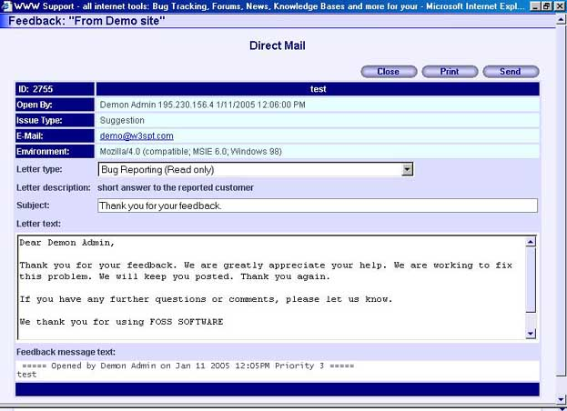

Fields
Letter type
Type of letter. You can enter only predefined letter types. For managing of letter types list use the "SAdmin: Mail Templates: Template Configuration" page.
Subject
Subject of the letter.
Letter text
Letter text.

Buttons
Close
Closes window.
Print
Opens print version of the current page.
Send
Sends letter.

"Feedback: Configuration" page
Use this page to manage lists of statuses and issue types.

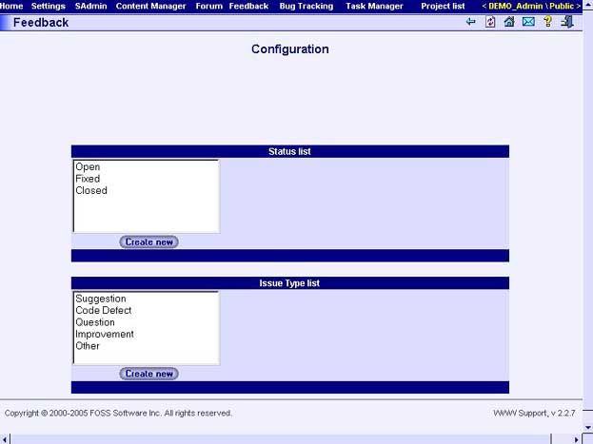

Buttons
Create new
Creates status or issue type.
Delete
Deletes status or issue type.

"Feedback: Subscription" page
Use this page to manage your subscription to the zone events. Information about subscription is displayed in the table which contains one row for each available zone.

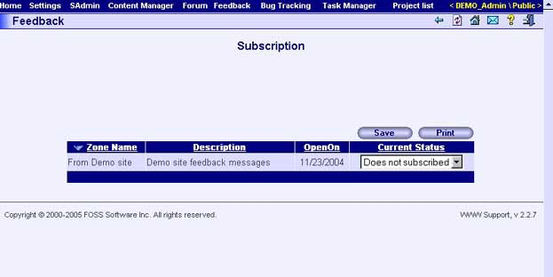

Table Columns
Zone Name
Name of the zone.
Description
Brief description of the zone.
OpenOn
Zone creation date.
Current Status
Combo box containing the list of available subscription type. Choose the subscription type you need.

Buttons
Save
Saves subscription settings.
Print
Opens print version of the current page.

"Feedback: Activity Report" page
Use this page to view statistics about user activity in the "Feedback" subsystem.

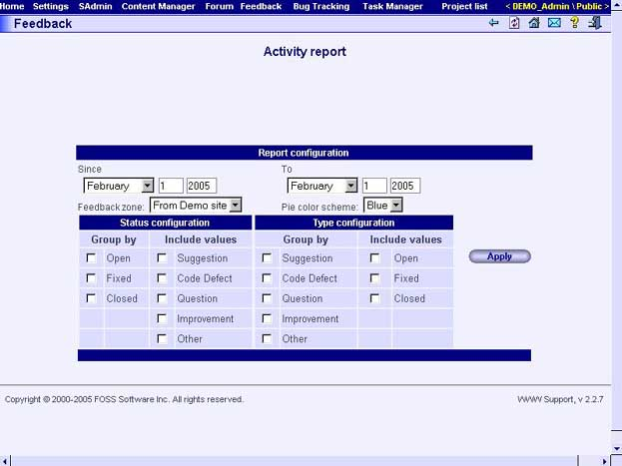

Fields
Since
Begin date of the activity report.
To
End date of the activity report.
Feedback Zone
Feedback zone of activity report.
Pie Color Scheme
Color scheme of activity chart.

Buttons
Apply
Shows the zone activity chart corresponding to entered parameters.

"Feedback: User Activity Report" page
Use this page to view statistics about user activity in the "Feedback" subsystem.

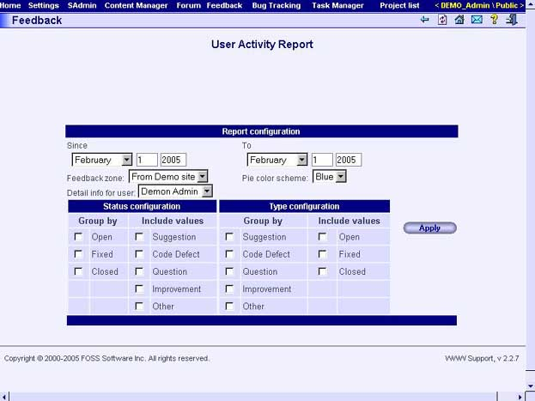

Fields
Since
Begin date of the users’ activity report.
To
End date of the users’ activity report.
Feedback Zone
Feedback zone of users’ activity report.
Pie Color Scheme
Color scheme of users’ activity chart.
Detail Info for User
Choose which user the activity report will be showed for.

Buttons
Apply
Shows the user activity chart corresponding to entered parameters.

"Bug Tracking" subsystem

"Bug Tracking: Issue List" page
Use this page to manage bug tracking issues. The page displays information about available issues in the table which contains one row for each issue.

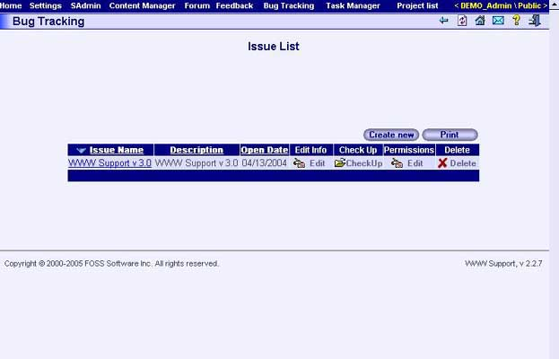

Table Columns
Issue Name
Name of the issue.
Description
Brief description of the issue.
Open Date
Issue creation date.
Edit Info
The column contains the "Edit" button. Pressing this button you open the "Bug Tracking: Edit Issue Information: [issue]" page.
Check Up
The column contains the "Check Up" button. Pressing this button you open the "Bug Tracking: Message List: [issue]" page there you can test an issue appearance.
Permissions
The column contains the "Edit" button. Pressing this button you open the "Bug Tracking: Edit Permissions: [issue]" page where you can configure users’ permissions.
Delete
The column contains the "Delete" button. Pressing this button you can delete corresponding issue.

Buttons
Create New
Opens the "Bug Tracking: Create New Issue" page for the purpose of creating new issue.
Print
Opens print version of the current page.

"Bug Tracking: Create New Issue" page
Use this page to create new issue.

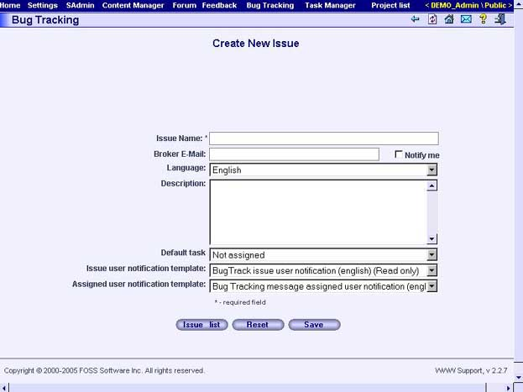

Fields
Issue Name
Name of new issue.
Broker E-mail
E-mail of issue responsible person.
Notify me
If checkbox is checked, issue responsible person will receive the notifications about new issue messages.
Language
Language of issue.
Description
Brief description of issue.
Default task
Default task for issue.
Issue user notification template
Mail template used for notification to users about new message in issue.
Assigned user notification template
Mail template used for notification to users about new message assigned to him in issue.

Buttons
Issue List
Opens the "Bug Tracking: Issue List" page.
Reset
Clears all form fields.
Save
Creates a new issue.

"Bug Tracking: Edit Issue Information: [issue]" page
Use this page to update issue information.

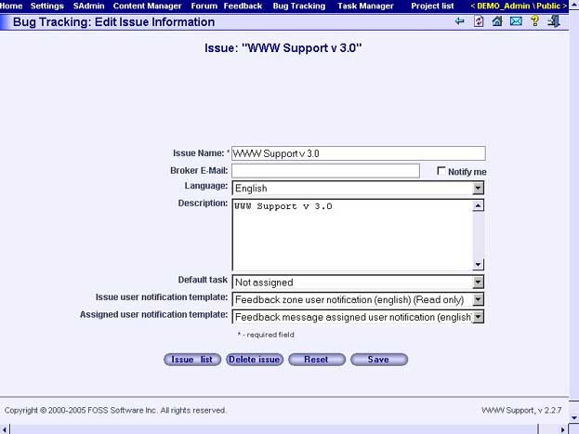

Fields
Issue Name
Name of the issue.
Broker E-mail
E-mail of issue responsible person.
Notify me
If checked, issue responsible person will receive the notifications about new issue messages.
Language
Language of issue.
Description
Brief description of issue.
Default task
Default task for issue.
Issue user notification template
Mail template used for notification to users about new message in issue.
Assigned user notification template
Mail template used for notification to users about new message assigned to him in issue.

Buttons
Issue List
Opens the "Bug Tracking: Issue List" page.
Delete Issue
Deletes issue.
Reset
Clears all form fields.
Save
Updates issue information.

"Bug Tracking: Edit Permissions: [issue]" page
Use this page to manage user permissions to the certain issues. The name of selected issue is shown in the page title. Information about users’ permissions is displayed in the table which contains one row for each user’s role.

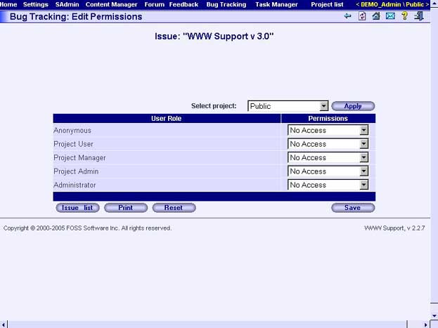

Table Columns
User Role
The name of the user role.
Permissions
The list of user role permissions.

Fields
Select project
Combo which contains a list of projects. Choose the project to which you want to assign permissions.

Buttons
Issue List
Opens the "Bug Tracking: Issue List" page.
Print
Opens print version of the current page.
Reset
Clears all form fields.
Save
Saves permissions information.

"Bug Tracking: Message List: [issue]" page
Use this page to view the issue message list. The name of the selected issue is shown as the page title. Information about issue messages is displayed in the table which contains one row for each message.

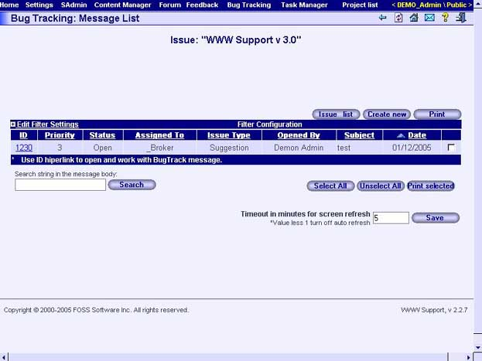

Table columns
ID
Number of message. Text of column implemented as hyperlink to the "Bug Tracking: [issue]: Message Details" page which displays corresponding message.
Priority
Value of message priority.
Status
Status of the message.
Assigned To
Name of the issue responsible user.
Issue type
Type of issue message.
Opened By
Name of the user who has created the message.
Subject
Subject of the issue message.
Date
Creation date of the message.
Selection column
The column contains the checkboxes for selection of messages. Selection can be used later, for example, for printing selected messages.

Fields
Search string in the message body
This field allows filtering the messages displayed in the message list table. Press "Search" button after specifying filter to apply it. You will then see only messages which contain the specified search string.
Timeout in minutes for screen refresh
Use this field for specifying the automatic refresh period of the page in minutes. Press "Save" button to apply changes.

Buttons
Issue List
Shows the "Bug Tracking: Issue List" page.
Create New
Opens the "Bug Tracking: [issue]: Create New Message" page for creation of new messages.
Print
Opens print version of the current page.
Select all
Selects all messages in the messages list table.
Unselect all
Unselects all messages in the messages list table.
Print selected
Opens page for printing of the selected messages.

"Bug Tracking: [issue]: Create New Message" page
Use this page to create new messages about problems.

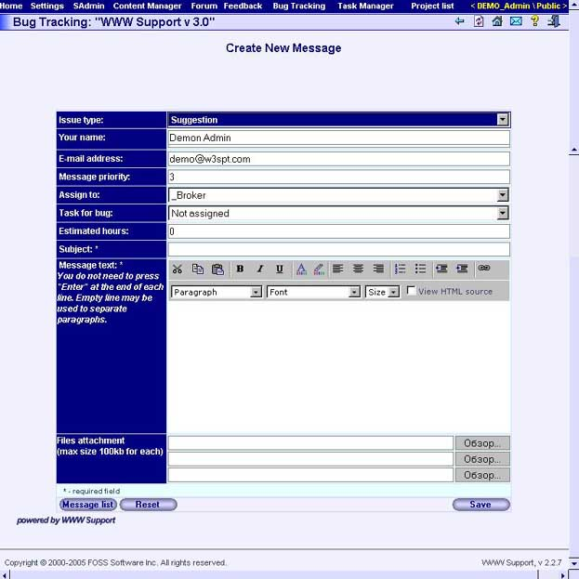

Fields
Issue Type
Type of new issue message, for example: "suggestion", "question", "code defect", etc. You can enter only predefined issue types. For managing of issue types list use the "Bug Tracking: Configuration" page.
Your Name
This field contains your name by default.
E-mail address
This field contains your e-mail address by default.
Message priority
Value of message priority.
Assign To
Name of the message responsible user.
Task for bug
Name of the task for bug.
Estimated hours
Estimated hours for task.
Subject
Subject of the issue message.
Message Text
Message text.
Files attachment
You can attach any 3 files which are not more than 500K each.

Buttons
Message List
Shows the "Bug Tracking: Message List: [issue]" page
Reset
Clears all form fields.
Save
Creates new issue message.

"Bug Tracking: [issue]: Message Details" page
Use this page to view issue message properties.

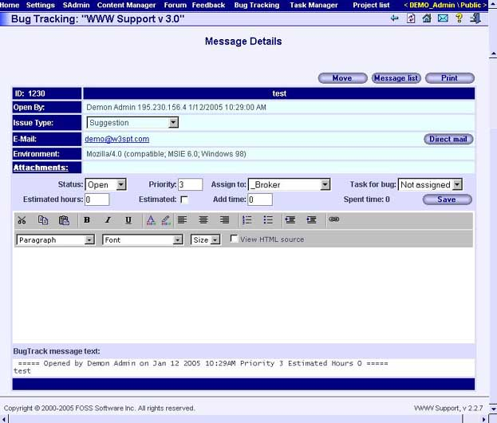

Fields
ID
Message number.
Subject
Message subject.
Open By
Name of the person who created the message.
Issue Type
Issue type.
E-mail
E-mail of the person who created the message.
Environment
Technical information about user’s browser.
Attachments
Information about attachments in the message.
Status
Message status.
Priority
Message priority.
Assign To
Name of the message responsible person.
Task for Bug
Name task for bug.
Estimated hours
Estimated hours for task.
Estimated
The check box which sets "estimated" property of the task.
Add Time
Add time for task.
Text
Message text.

Buttons
Previous
Shows the previous message.
Next
Shows the next message.
Move
Use this button to move the message to any zone of the "Feedback" subsystem or to the "Bug Tracking" subsystem.
Message List
Opens the "Bug Tracking: Message List: [issue]" page.
Print
Opens print version of the current page.
Save
Saves changes in the message properties.
Direct mail
Using this button you can send an e-mail to the message creator. After pressing the button you will see the "Bug Tracking: [issue]: Direct Mail" page where you can choose mail template, edit and send e-mail.

"Bug Tracking: [issue]: Direct Mail" page
Use this page to create and to send letters to the bug tracking message creator.

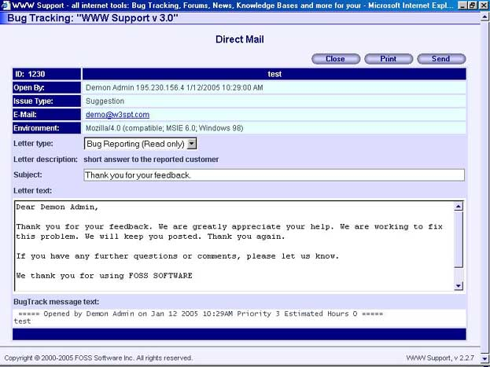

Fields
Letter type
Type of letter. You can enter only predefined letter types. For managing of letter types list use the "SAdmin: Mail Templates: Template Configuration" page.
Subject
Subject of the letter.
Letter text
Letter text.

Buttons
Close
Closes window.
Print
Opens print version of the current page.
Send
Sends letter.

"Bug Tracking: Configuration" page
Use this page to manage lists of statuses and issues types.

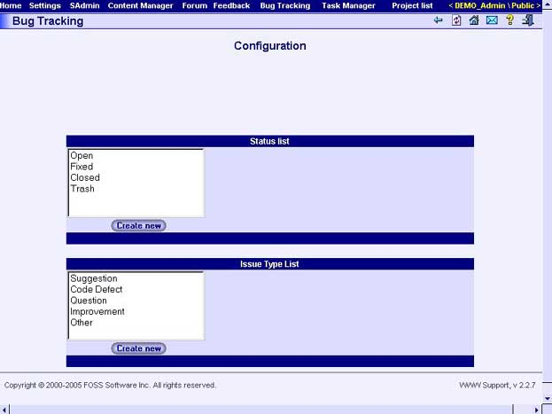

Buttons
Create
Creates status or issue type.
Delete
Deletes status or issue type.

"Bug Tracking: Subscription" page
Use this page to manage your subscription to the issue events. Information about subscriptions are displayed in the table which contains one row for each available issue.

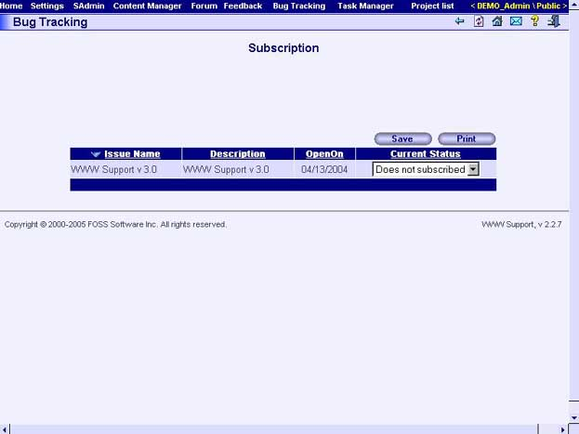

Table Columns
Issue Name
Name of the Issue.
Description
Brief description of the issue.
OpenOn
Issue creation date.
Current Status
Combo box containing the list of available subscription types. Choose the subscription type you need.

Buttons
Save
Saves subscription settings.
Print
Opens print version of the current page.

"Bug Tracking: Activity Report" page
Use this page to view statistics about user activity in the "Bug Tracking" subsystem.

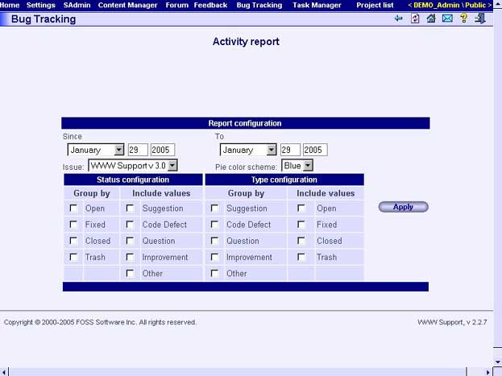

Fields
Since
Begin date of the activity report.
To
End date of the activity report.
Issue
Issue of activity report.
Pie Color Scheme
Color scheme of activity chart.

Buttons
Apply
Shows the issue activity chart corresponding to entered parameters.

"Bug Tracking: User Activity Report" page
Use this page to view statistics about user activity in the "Bug Tracking" subsystem.

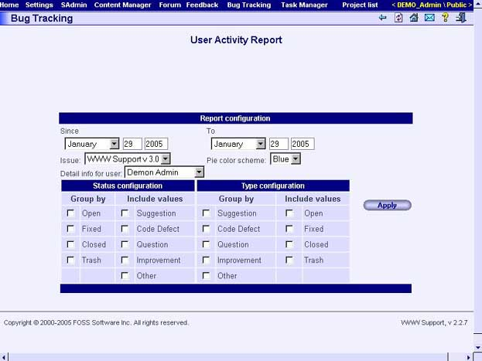

Fields
Since
Begin date of the user activity report.
To
End date of the user activity report.
Issue
Issue of user activity report.
Pie Color Scheme
Color scheme of users’ activity chart.
Detail Info for User
Choose user the activity report will be showed for.

Buttons
Apply
Shows the user activity chart corresponding entered parameters.

"Task Manager" subsystem

"Task Manager: Task List" page
Use this page to manage project tasks. Information about tasks is displayed in the table which contains one row for each task.

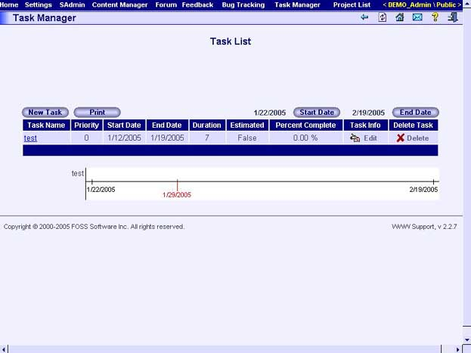

Table Columns
Task Name
Name of the task - field value is implemented as hyperlink to the "Task Manager: Task Information: [task]" page which displays information about corresponding task.
Priority
Priority of the task.
Start Date
Specifies a start date of the task.
End Date
Specifies a due date of the task.
Duration
Duration of the task.
Estimated
The check box which sets "estimated" property of the task.
Percent Complete
The percentage of task completion.
Task Info
Column contains the "Edit" button. Use this button to open the "Task Manager: Edit Task Information: [task]" page where you can change properties of the corresponding task.
Delete Task
Column contains the "Delete" button. Use this button to delete corresponding task.

Buttons
New Task
Button opens the "Task Manager: Create New Task" page.
Print
Opens print version of the current page.
Start Date
Button sets the start date of the tasks which are shown in the tasks list table.
End Date
Button sets the end date of the tasks which are shown in the tasks list table.

"Task Manager: Task Information: [task]" page
Use this page to view/edit task information.

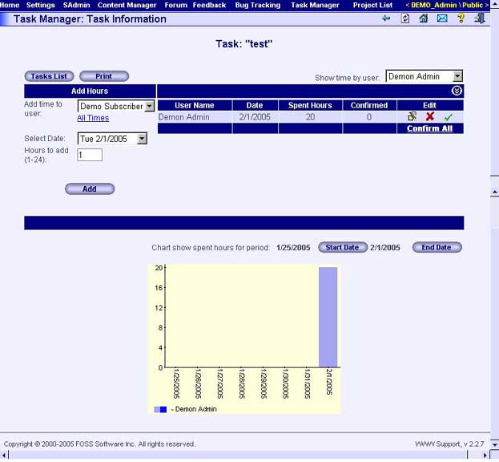

Fields
Show time by user
Choose user the report will be showed for.
Add time to user
Choose user the time will be added for.
Select Date
Start date.
Hours to add (1-24)
Number of hours will be added.

Buttons
Add
Adds times for corresponding user.

"Task Manager: Create New Task" page
Use this page to create a task. With this page you can specify all options required to create a task.

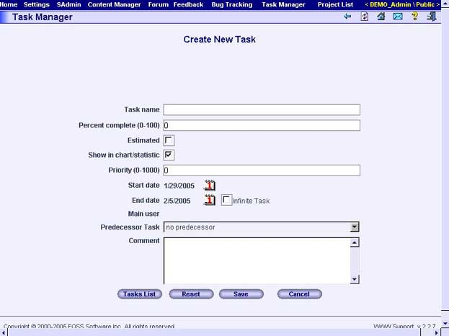

Fields
Task Name
The name of the new task to create.
Percent complete (0-100)
The percentage of task completion.
Estimated
The check box which sets "estimated" property of the task.
Show in charts/statistics
Check to enable use of the task in Charts and Statistics.
Priority (0-1000)
Indicates a priority of the new task.
Start Date
Specifies a start date of the new task. Press the calendar icon to change the date.
End Date
Specifies a due date of the new task. Press the calendar icon to change the date.
Predecessor Task
Use the drop-down list to select a task which you want your new task to be part of.
Comment
Specify brief info about the task. It is an optional field for such things as: make the reason for the task clearer, describe the task fully, etc

Buttons
Tasks list
Shows the "Task Manager: Task List" page.
Reset
Use this button to clear all the fields of the page.
Save
Creates a new task with specified parameters.
Cancel
Closes the current page without creation of the new task.

"Task Manager: Edit Task Information: [task]" page
Use this page to view/edit task information.

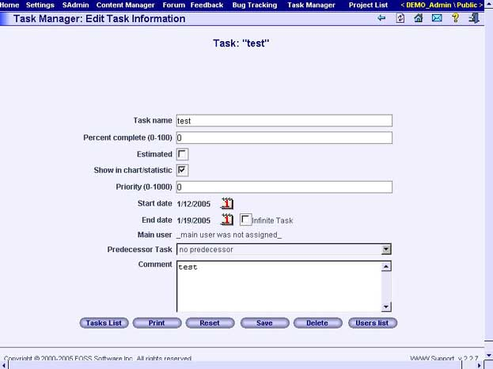

Fields
Task Name
The name of the new task to create.
Percent complete (0-100)
The percentage of task completion.
Estimated
The check box which sets "estimated" property of the task.
Show in charts/statistics
Check to enable use of the task in Charts and Statistics.
Priority (0-1000)
Indicates a priority of the new task.
Start Date
Specifies a start date of the new task. Press the calendar icon to change the date.
End Date
Specifies a due date of the new task. Press the calendar icon to change the date.
Predecessor Task
Use the drop-down list to select a task to which you want your new task to be part of.
Comment
Specify brief info about the task. It is an optional field for such things as: make the reason for the task clearer, describe the task fully, etc

Buttons
Tasks list
Shows the "Task Manager: Task List" page.
Print
Shows print version of the current page.
Reset
Use this button to clear all the fields of the page.
Save
Creates a new task with the specified parameters.
Delete
Deletes the task.
Users List
Shows the "Task Manager: Involved Users: [task]" page.

"Task Manager: Involved Users: [task]" page
Use this page to specify managers and performers of the task . Move users from the Non Assigned Users list to the Assigned Users list to define all performers of the task. You can also remove a users from the task by deleting them from the Assigned User list.

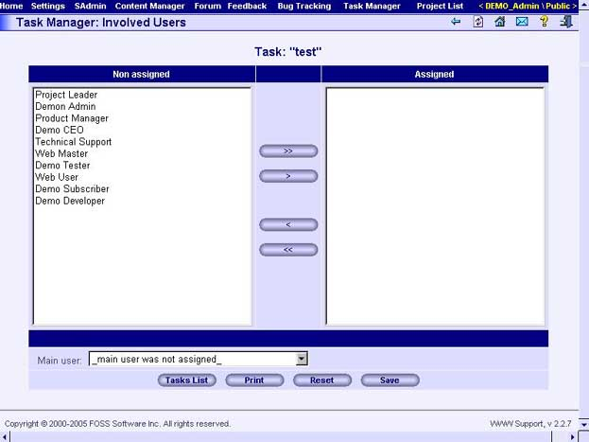

Fields
Assigned
The list of task performers. Use arrow buttons to add and remove users from the list.
Not assigned
The list of users who are potential performers of the task. Use arrow buttons to add and remove users from the list.
Main User
Use the drop-down list to select a task manager from a list of available users.

Buttons
Arrow buttons
Use arrow buttons to move users from one list box to the other. To move a user, please, select the user in the list and click one of the arrow buttons ( > or < ).
Tasks list
Shows "Task Manager: Task List" page.
Print
Shows print version of the current page.
Reset
Use this button to clear all fields of the page.
Save
Saves all changes.

"Task Manager: Edit Permissions: Task Access Permissions" page
Use this page to manage users’ permissions to the tasks of project. Information about user permissions is displayed in the table which contains one row for each user’s role.

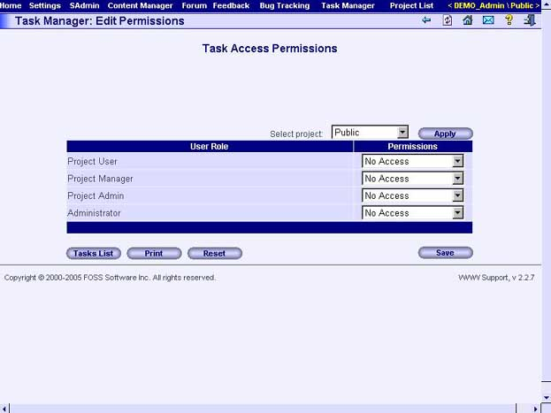

Table Columns
User Role
The name of the user role.
Permissions
The list of group permissions.

Fields
Select project
Combo box which contains the list of projects. Choose the project to which you want to assign permissions.

Buttons
Tasks List
Shows the "Task Manager: Task List" page.
Print
Opens print version of the current page.
Reset
Clears all form fields.
Save
Saves permissions information.

"Task Manager: Task Statistics" page
Use this page to view statistics about user activity in the "Task Manager" subsystem. Specify all report configuration parameters and press "Apply" button to view task statistics.

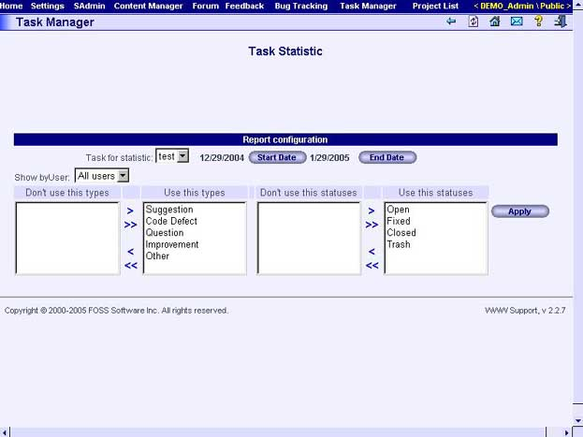

Fields
Task for Statistic
Choose task the report will be created for.
Start Date
Start date of the report statistics.
End Date
Finish date of the report statistics.
Show by User
Choose user the report will be showed for.

Buttons
Apply
Shows the users’ activity report corresponding entered parameters.

"Site Management" subsystem

"Site Management: Site List" page
Use this page to manage sites. Information about sites is displayed in the table which contains one row per each site.

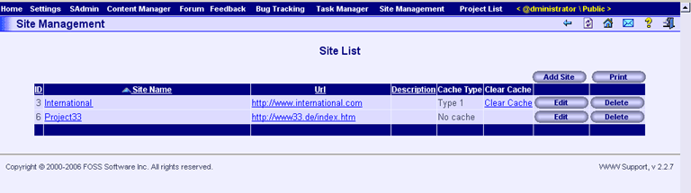

Table Columns
ID
ID number of the site
Site Name
Name of the site - field value is implemented as hyperlink to the "Site Management: Menu Editor" page which displays information about inner structure of the site in a tree-like form and enables to select any page of the site for its editing.
URL
URL of the page (Must be relative address, i.e. “Default.aspx”).
One of the web service methods for the Site Management requires a relative URL of the page as its parameter. Then this method searches for this relative URL in the database and returns all the stored information about the selected page.
Description
Any user defined description for the site.
Cache Type
Choose cache type for the selected site. This field can have two values: “Type 1” and “No Cache”. Sites can cache all the information stored in the database for faster queries processing. Remote sites, which track "ClearCache=1" parameter in URL query, reset their cache independently and reread data from database. Such sites are comprising CacheType 1 sites group.
Clear Cache
This field value is implemented as hyperlink and clears the cache of the remote site when selected. When clicking Clear Cache link, www.w3spt.com generates adressing to the remote site with "ClearCache=1" parameter in URL query, i.e. initiates "reset cache" manually.

Buttons
Add Site
Button opens the "Site Management: Add New Site" page.
Print
Opens print version of the current page.
Edit
Opens the "Site Management: Menu Editor" page for the selected site.
Delete
Deletes the selected site.

"Site Management: Add New Site" page
Use this page to add new site. Information about sites is displayed in the table which contains one row per each site.

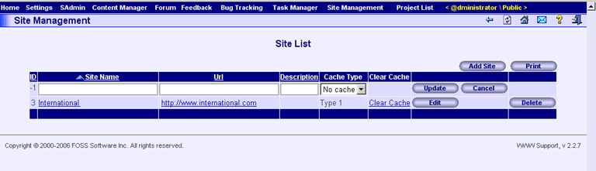

Table Columns
ID
ID number of the site
Site Name
Name of the site - field value is implemented as hyperlink to the "Site Management: Menu Editor" page which displays information about inner structure of the site in a tree-like form and enables to select any page of the site for its editing.
URL
URL of the page (Must be relative address, i.e. “Default.aspx”).
One of the web service methods for the Site Management requires a relative URL of the page as its parameter. Then this method searches for this relative URL in the database and returns all the stored information about the selected page.
Description
Any user defined description for the site.
Cache Type
Choose cache type for the selected site. This field can have two values: “Type 1” and “No Cache”. Sites can cache all the information stored in the database for faster queries processing. Remote sites, which track "ClearCache=1" parameter in URL query, reset their cache independently and reread data from database. Such sites are comprising CacheType 1 sites group.
Clear Cache
This field value is implemented as hyperlink and clears the cache of the remote site when selected. When clicking Clear Cache link, www.w3spt.com generates adressing to the remote site with "ClearCache=1" parameter in URL query, i.e. initiates "reset cache" manually.

Buttons
Add Site
Button opens the "Site Management: Add New Site" page.
Print
Opens print version of the current page.
Update
Saves entered changes.
Cancel
Closes the current page without creation of the new site.
Edit
Opens the "Site Management: Menu Editor" page for the selected site.
Delete
Deletes the selected site.

"Site Management: Edit Site" page
Use this page to edit site. Information about sites is displayed in the table which contains one row per each site.

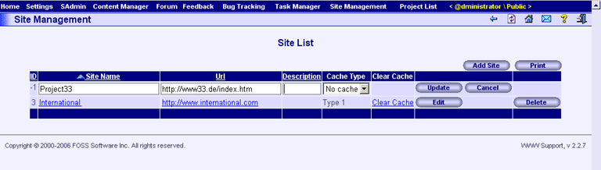

Table Columns
ID
ID number of the site
Site Name
Name of the site - field value is implemented as hyperlink to the "Site Management: Menu Editor" page which displays information about inner structure of the site in a tree-like form and enables to select any page of the site for its editing.
URL
URL of the page (Must be relative address, i.e. “Default.aspx”).
One of the web service methods for the Site Management requires a relative URL of the page as its parameter. Then this method searches for this relative URL in the database and returns all the stored information about the selected page.
Description
Any user defined description for the site.
Cache Type
Choose cache type for the selected site. This field can have two values: “Type 1” and “No Cache”. Sites can cache all the information stored in the database for faster queries processing. Remote sites, which track "ClearCache=1" parameter in URL query, reset their cache independently and reread data from database. Such sites are comprising CacheType 1 sites group.
Clear Cache
This field value is implemented as hyperlink and clears the cache of the remote site when selected. When clicking Clear Cache link, www.w3spt.com generates adressing to the remote site with "ClearCache=1" parameter in URL query, i.e. initiates "reset cache" manually.

Buttons
Add Site
Opens the "Site Management: Add New Site" page.
Print
Opens print version of the current page.
Update
Saves entered changes.
Cancel
Closes the current page without saving changes.
Edit
Opens the "Site Management: Menu Editor" page for the selected site.
Delete
Deletes the selected site.

"Site Management: Menu Editor" page
This page is divided into two sections: Tree-like structure of the current site, where user can select necessary page, is placed in the left part of a screen. Table-like structure of the selected page is placed in the middle of a screen. Use this tree to expand/collapse necessary branches, which represent menu items of the site and their corresponding pages. Every selected page is displayed in the middle of a screen as a set of fields in a table, and each of this fields can be edited.

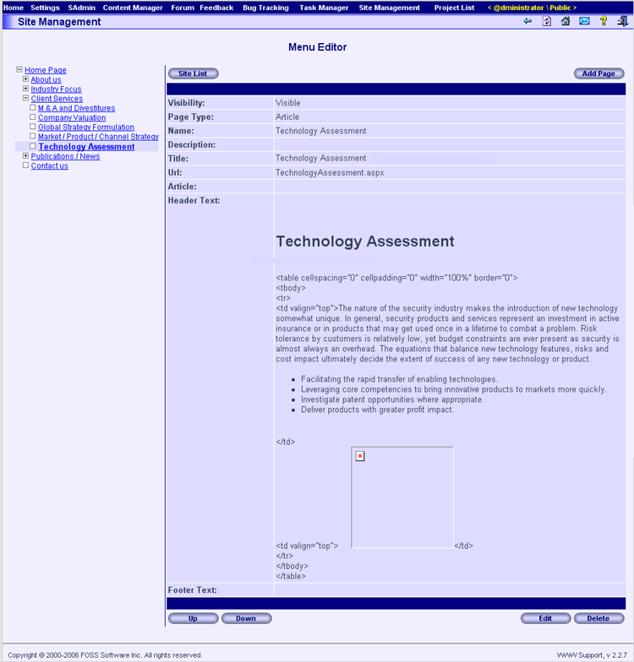

Table Columns
Visibility:
Visibility of the selected page (Visible / Invisible).
Page Type:
Type of the selected page (Article / Theme).
Name:
Name of the selected page as seen in a tree. Mandatory field.
Description:
Description of the selected page. May be empty.
Title:
Title of the selected page (is published in the Internet). May be empty.
URL:
URL of the page (Must be relative address, i.e. “Default.aspx”).
One of the web service methods for the Site Management requires a relative URL of the page as its parameter. Then this method searches for this relative URL in the database and returns all the stored information about the selected page.
Article:
Any article from the "Content Manager: [category]: Articles List: [theme]" page
Header Text:
HTML code for the header of the selected page here.
Footer Text:
HTML code for the footer of the selected page here.

Buttons
Site List
Opens the "Site Management: Site List" page.
Add Page
Opens the "Site Management: Page Info Edit: Add New Page" page.
Up
Moves the selected page one page up.
Down
Moves the selected page one page down.
Edit
Opens the "Site Management: Page Info Edit: Edit Page" page page for the selected page.
Delete
Deletes the selected page (only home page, i.e. parental to all the other pages could not be deleted). If selected page has any child pages, they will be deleted as well.

"Site Management: Menu Editor: Page Info Edit (Add Page)" page
This page is required for adding of a new page and its information into the selected in the "Site Management: Menu Editor" page branch. The page contains mandatory fields (Parent Page, Visibility, Page Type, Name) and non-mandatory (Description, Title, URL, Article, Header Text and Footer Text) fields. WYSIWYG button panels placed inside Header Text and Footer Text fields enable you to input required HTML code into the header and footer of a new page.

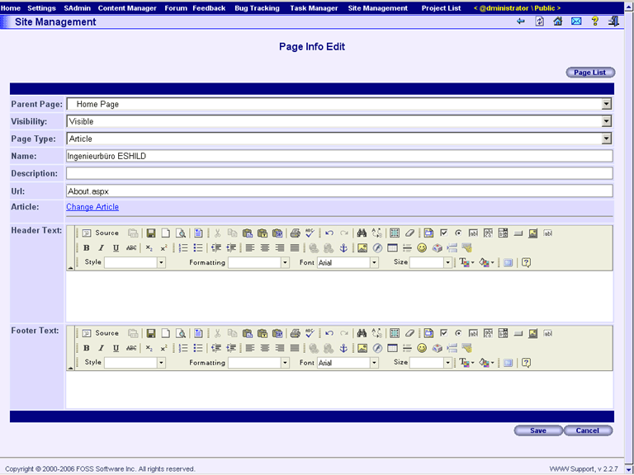

Table Columns
Parent Page:
Enter the name of the parent page here (if this one exists). Depending on the position of your highlight in the hierarchy tree in the "Site Management: Menu Editor" page, this field is filled automatically, but can be changed.
Visibility:
Visibility of the selected page (Visible / Invisible). Visible is default.
Page Type:
Type of the selected page (Article / Theme). Article is default.
Name:
Name of the selected page as seen in a tree.
Description:
Description of the selected page. You may put any description here.
Title:
Title of the selected page (is published in the Internet).
URL:
URL of the page (Must be relative address, i.e. “Default.aspx”).
One of the web service methods for the Site Management requires a relative URL of the page as its parameter. Then this method searches for this relative URL in the database and returns all the stored information about the selected page.
Article:
When you click on Change Article link, you can select any article from the "Content Manager: [category]: Articles List: [theme]" page and insert this article into the current page contents.
Header Text:
Enter HTML code for the header of the selected page here. Use WYSIWIG toolbar buttons and fields for creation and editing of HTML code of your page.
Footer Text:
Enter HTML code for the footer of the selected page here. Use WYSIWIG toolbar buttons and fields for creation and editing of HTML code of your page.

Buttons
Page List
Opens the "Site Management: Menu Editor" page.
Save
Saves entered changes.
Cancel
Closes the current page without saving changes.

Other Controls
Toolbars located in sections “Header Text” and “Footer Text” contain buttons and fields for site editing and represent a WEB-based HTML page editor, which works at WYSIWYG principle. You may insert your own HTML code as well.

"Site Management: Menu Editor: Page Info Edit (Edit Page)" page
This page is required for adding of a new page and its information into the selected in the "Site Management: Menu Editor" page branch. The page contains mandatory fields (Parent Page, Visibility, Page Type, Name) and non-mandatory (Description, Title, URL, Article, Header Text and Footer Text) fields. WYSIWYG button panels placed inside Header Text and Footer Text fields enable you to input required HTML code into the header and footer of an edited page.

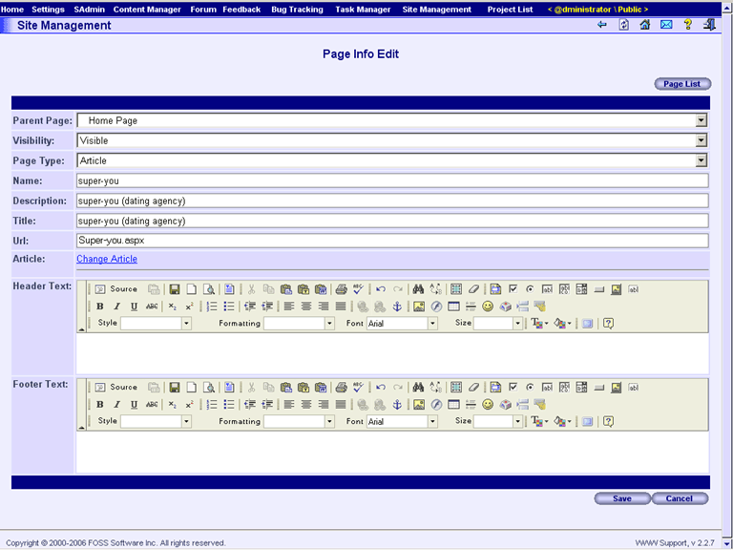

Table Columns
Parent Page:
Enter the name of the parent page here (if this one exists). Depending on the position of your highlight in the hierarchy tree in the "Site Management: Menu Editor" page, this field is filled automatically, but can be changed.
Visibility:
Visibility of the selected page (Visible / Invisible). Visible is default.
Page Type:
Type of the selected page (Article / Theme). Article is default.
Name:
Name of the selected page as seen in a tree.
Description:
Description of the selected page. You may put any description here.
Title:
Title of the selected page (is published in the Internet).
URL:
URL of the page (Must be relative address, i.e. “Default.aspx”).
One of the web service methods for the Site Management requires a relative URL of the page as its parameter. Then this method searches for this relative URL in the database and returns all the stored information about the selected page.
Article:
When you click on Change Article link, you can select any article from the "Content Manager: [category]: Articles List: [theme]" page and insert this article into the current page contents.
Header Text:
Enter HTML code for the header of the selected page here. Use WYSIWIG toolbar buttons and fields for creation and editing of HTML code of your page.
Footer Text:
Enter HTML code for the footer of the selected page here. Use WYSIWIG toolbar buttons and fields for creation and editing of HTML code of your page.

Buttons
Page List
Opens the "Site Management: Menu Editor" page.
Save
Saves entered changes.
Cancel
Closes the current page without saving changes.

Other Controls
Toolbars located in sections “Header Text” and “Footer Text” contain buttons and fields for site editing and represent a WEB-based HTML page editor, which works at WYSIWYG principle. You may insert your own HTML code as well.

Using "Site Management" subsystem

What do you need to add a new site

Simply open "Site Management: Site List" page using the corresponding upper menu item.
Use this page to manage sites. Information about sites is displayed in the table which contains one row per each site.

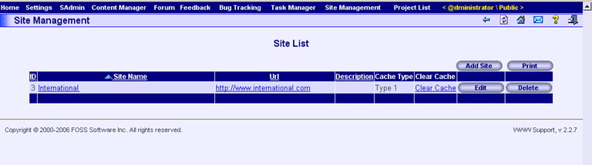

Follow these few steps carefully.

a. Press the “Add Site” button. The screen will look like this:

b. Input site name and URL of your site into the corresponding fields. The screen will look like this:

You may enter some description to the new site and select cache type. These fields are not mandatory.

c. If you are not satisfied with your input or if you have made some mistakes, you may press “Cancel” button and your input will be ignored.

d. If all the fields are correctly filled, press “Update” button and the new site will be added to the system.

The screen will look like this:

For further editing of your new site, select the corresponding link to your site (for example, click on the “Project 33” hyperlink in the “Site Name” field). Clicking on “URL” field will result opening of a real site.

What do you need to add new pages and build hierarchy of a new site

After clicking on the Site Name, your screen will look like this:

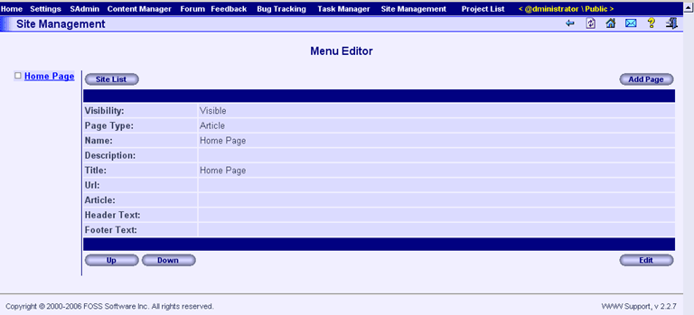

Previously input URL will be recognized by system as a home page. Now you may add all the other necessary pages.

Follow these steps carefully.

a. Press the “Add Page” button, and your screen will look like this:

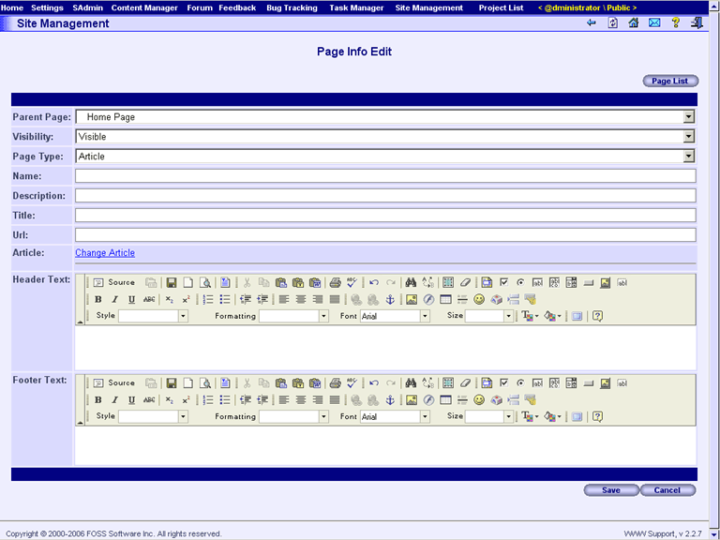

b. Input “Name”, “Description”, “Page Title”, “URL”. Input “Header Text” and “Footer Text” in HTML format if necessary. Note that Page Name and URL are mandatory fields, all the others – not. The screen will look like this:

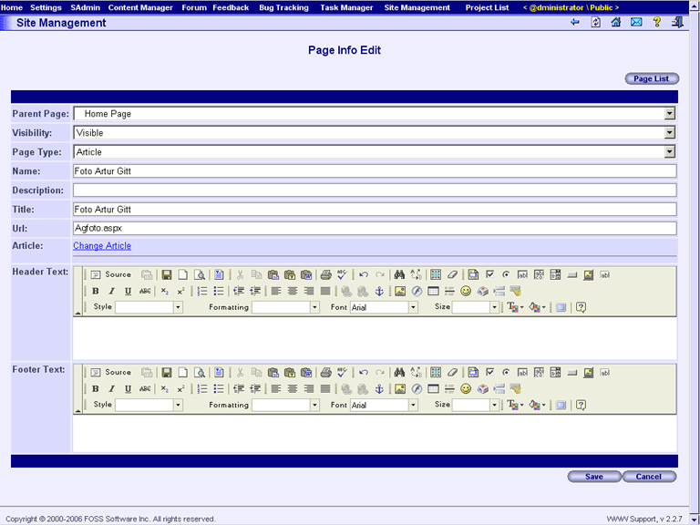

You can manage visibility of your page by selecting required value in the corresponding field. You may change hierarchy level of your page by selecting the corresponding Parent Page name. You can change page type making the corresponding selection. Use any fields or buttons in the Header Text and Footer Text sections to edit HTML code of your page header and footer correspondingly. All of the controls located on these toolbars may be used at WYSIWYG principle. You may insert your own HTML code as well.
Pressing the “Cancel” button will cancel your input. Pressing the “Site List” button will return you to Menu Editor screen.

c. Press “Save” button. Your input will be saved, and you will be returned to Menu Editor screen:

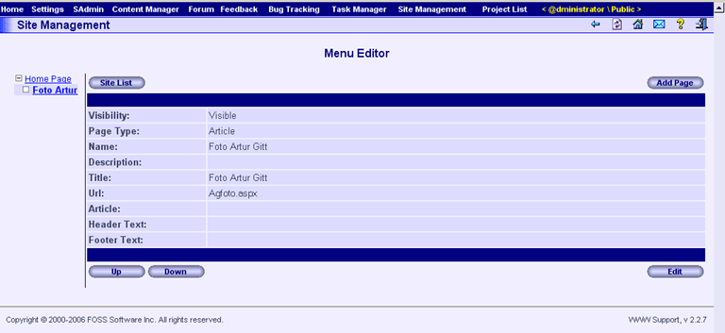

d. Now you may highlight any level of your hierarchy using the Site Structure Tree in the left part of a Menu Editor screen. If you need to add some page(s) inside newly added page, simply press the “Add Page” button. Your screen will look like this:

Follow the instructions of (b) – (c) steps. After pressing the “Save” button you will be returned to Menu Editor screen, which will look like this:

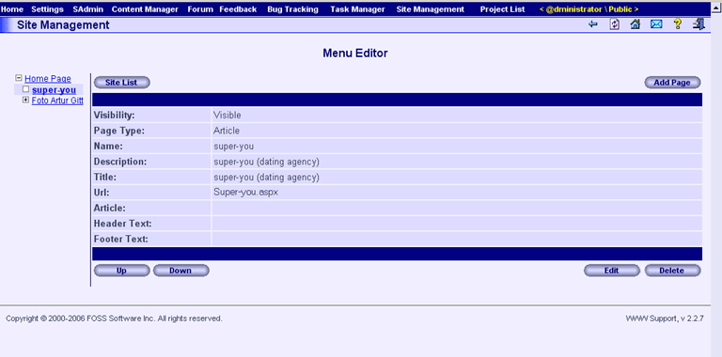

If you need to add some pages to the any hierarchy level, highlight the corresponding level in the Site Structure Tree and repeat steps (b) – (c) so many times as necessary. This feature works on any hierarchy level.

After a number of pages will be added, your screen will look like this:

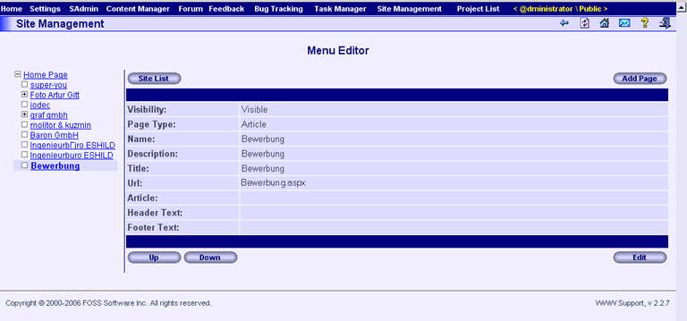

What is required to manage branches and pages
Now you can manage branches of your Site Structure Tree using two buttons – “Up” and “Down”. If you need some pages to be placed higher, highlight the required Page Name in the tree and press “Up” button. If you need some pages to be placed lower, highlight the required Page Name in the tree and press “Down” button. Note that one press of an “Up” or “Down” button moves your highlighted page one step higher or lower. You may expand/collapse some tree branches, which have pages inside them. You may edit highlighted pages using “Edit” button and even change their hierarchy position, selecting the corresponding “Parent Page” on the "Site Management: Menu Editor: Page Info Edit (Edit Page)" page (step (b) of “What do you need to add new pages and build hierarchy of a new site ” paragraph).

What is required to delete some pages
To delete one or more pages, you have to select required page in your Site Structure Tree and press “Delete” button. If the selected page contains child pages, all of them will be deleted as well. Note, that this feature does not work with the root (Home) page. To delete the home page you may follow the instructions described below (What is required to delete the entire site) and delete the entire site.

After pressing “Delete” button your screen will look like this:
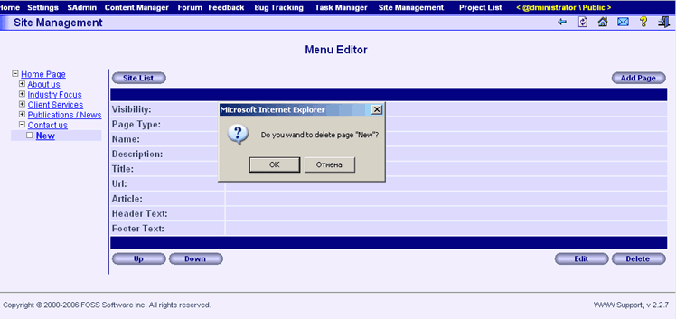
To confirm deletion of the selected page (-s) from the system, press OK button.

What is required to delete the entire site

If you need to delete the entire site, you have to press “Delete” button on the "Site Management: Site List" page.
Your screen will look like this:

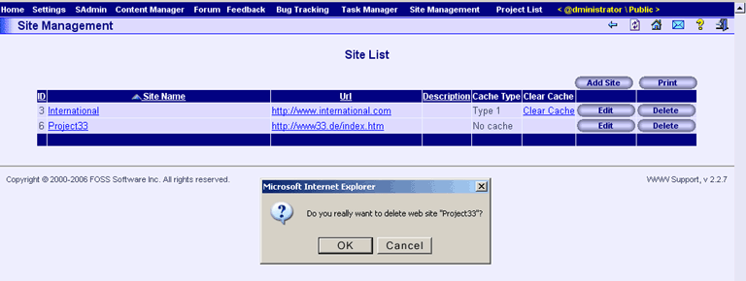

To confirm deletion of the entire site from the system, press OK button.

Support
You can find the additional information about the product and how to get our technical support on the product site http://www.w3spt.com. Technical support of the system is carried out in a mode 24 hours per day of 7 days per week. You have an opportunity to ask our experts consultation for various questions about using the system and how WWW Support can help optimize your business process.

